

**Management & Science University,  
University Drive, Off Persiaran Olahraga,  
Section 13, 40100 Shah Alam,  
Selangor Darul Ehsan.**

**POSTGRAD THESIS MONITORING and CONTROLLING SYSTEM**

**(PGTMCS)**

**USER MANUAL for FACULTY**

Version 1.0

Document Reference: MSU/PGTMCS/UM/002

**DOCUMENT DETAILS**

|  |  |
| --- | --- |
| **Effective Date:** | 1st May 2015 |
| **Document Owner:** | Information Technology and Innovation Centre (ITIC) |

**REVISION HISTORY**

|  |  |  |  |
| --- | --- | --- | --- |
| **Date** | **Version** | **Description** | **Author** |
| 18th February 2015 | 0.1 | Document creation | Zuraimi, Amalina |
| 02nd March 2015 | 0.2 | Document review and update | Zuraimi |
| 19th May 2015 | 1.0 | Final | Zuraimi , Nizam |

**TABLE OF CONTENTS**

1 INTRODUCTION 6

1.1 Scope 6

1.2 System Requirement 6

1.2.1 URL 6

1.2.2 Internet Browser 6

1.2.3 User Access 7

1.3 Screen Design 7

2 HIGHLEVEL FLOW 9

2.1 Thesis Proposal Submission Process Flow 9

3 USER LOGIN and LOGOUT 10

3.1 Login 10

3.2 Logout 10

4 CHANGE PASSWORD 12

4.1 Change Password 12

5 THESIS VIEW 13

5.1 Search Student via Thesis ID/Title 13

5.1.1 Student Profile Details 13

5.2 Search Student via Student Name/Matrix No 16

5.2.1 Student Profile Details 16

6 LIST OF APPROVED THESIS 20

6.1 List of Approved Thesis 20

6.2 Generate PDF File 21

7 ADMINISTRATION VIEW 22

7.1 Reviewer Feedback Approval 22

7.2 Proposal Confirmation List 24

7.2.1 Manage Proposal Confirmation 25

6.3 Proposal Cancellation 38

6.3.1 Enter Remark Cancellation 39

6.4 Assign Supervisor 40

6.5 Assign Reviewer 46

6.6 List of thesis proposal – Disapproved thesis by Senate 52

6.7 Generate File 53

Appendix 55

Thesis Proposal - Request Change 55

Thesis Proposal - Disapproved 56

**LIST OF FIGURES**

Figure 1: PGTMCS Screen Structure Design 8

Figure 2: Thesis Proposal Submission Process Flow 9

Figure 3: Login Page 10

Figure 4: Logout Page 11

Figure 5: Change Password Page 12

Figure 6: Thesis Tab 13

Figure 7: Student Profile Tab 14

Figure 8: List of Supervisor / Co-Supervisor 14

Figure 9: Subject Taken 15

Figure 10: Thesis Tab – Thesis History 15

Figure 11: Thesis Tab – List of Student 16

Figure 12: Thesis Tab – Student Profile 17

Figure 13: Thesis Tab - List of Supervisor / Co-Supervisor 17

Figure 14: Thesis Tab - Subject Taken 18

Figure 15: Thesis Tab – Thesis History 19

Figure 16: Thesis Tab – List of Thesis 20

Figure 17: Thesis Tab – List of Thesis PDF 21

Figure 18: Administration Tab – Reviewer Feedback Approval 22

Figure 19: Thesis Tab – Reviewer Feedback Approval (...cont’d) 23

Figure 20: Administration Tab – Reviewer Feedback Approval search result 23

Figure 21: Administration Tab – Proposal Confirmation 24

Figure 22: Administration Tab – Proposal Confirmation Searching Result 25

Figure 23: Administration Tab – Proposal Confirmation Status 26

Figure 24: Administration Tab – List of Thesis Proposal for Senate Approval 27

Figure 25: Administration Tab – Proposal Confirmation Remark 28

Figure 26: Proposal Confirmation – Edit Description of Attachment 29

Figure 27: Proposal Confirmation – Assign Supervisor Page 29

Figure 28: Proposal Confirmation – Search and Assign Supervisor 30

Figure 29: Proposal Confirmation – View Assigned Supervisor/Co-Supervisor 31

Figure 30: Proposal Confirmation – Change Supervisor/Co-Supervisor 31

Figure 31: Proposal Confirmation – List All Staffs (If no search criteria is provided) 32

Figure 32: Proposal Confirmation – List the Selected Staff (based on provided search criteria) 32

Figure 33: Proposal Confirmation – View and Edit Supervisor/Co-Supervisor Biodata 33

Figure 34: Proposal Confirmation – Assign Reviewer 34

Figure 35: Proposal Confirmation – Assign Reviewer Search Result 34

Figure 36: Proposal Confirmation – List of Assigned Reviewer 35

Figure 37: Proposal Confirmation – List of Assigned Reviewer 35

Figure 38: Proposal Confirmation – List All Reviewers (If no search criteria is provided) 36

Figure 39: Proposal Confirmation – List of Reviewer (based on provided search criteria) 36

Figure 40: Proposal Confirmation – Remarks by Faculty to Reviewer 37

Figure 41: Administration Tab – Proposal Cancellation Page 38

Figure 42: Administration Tab – Remark Cancellation Page 39

Figure 43: Administration Tab – List of Student under the Assign Supervisor Page 40

Figure 44: Administration Tab – Assign Supervisor/Co-Supervisor Page 41

Figure 45: Administration Tab – List of Staff for Supervisor / Co-Supervisor Selection 41

Figure 46: Administration Tab – Supervisor/Co-Supervisor Search Result 42

Figure 47: Administration Tab – List of Assigned Supervisor/Co-Supervisor 43

Figure 48: Administration Tab – List of Supervisor/Co-Supervisor for Update 43

Figure 49: Assign Supervisor – List of Staff (If no search criteria are provided) 44

Figure 50: Assign Supervisor – List of Staff (based on provided search criteria) 44

Figure 51: Assign Supervisor – Supervisor / Co-Supervisor Biodata Page for Update 45

Figure 52: Assign Reviewer – List of Student 46

Figure 53: Assign Reviewer Page 47

Figure 54: Assign Reviewer Search Result (If no search criteria is provided) 47

Figure 55: Assign Reviewer Search Result (Based on provided search criteria) 48

Figure 56: List of Assigned Reviewer Page 49

Figure 57: List of Assigned Reviewer for Update 49

Figure 58: Assign Reviewer Search Result (If no search criteria are provided) 50

Figure 59: Assign Reviewer Search Result (Based on provided search criteria) 50

Figure 60: Assign Reviewer – Enter Faculty Remark 51

Figure 61: Administration Tab – List of Disapproved Thesis 52

Figure 62: List of Disapproved Thesis PDF 53

# INTRODUCTION

Postgraduate Thesis Monitoring and Controlling System (PGTMCS) version 1.0.0 is a system for the Student, Supervisor, Faculty and Senate to monitor the status of thesis proposal from its initial stage toward to the end. It is not only use by the respective personnel to control and manage the quality of the thesis to meet the university standard but it also can be used to keep track all the communication between the student and university. The history can be retrieved to view the completed work or its progress.

The system contains the main modules which are Thesis Proposal Submission and Approval, Monthly Progress Report Review, Thesis Proposal Defense, Thesis Work Completion, Thesis Evaluation/Viva and Senate Endorsement.

The Thesis Proposal Submission and Approval module will be the first release made available for use by the student and staffs. The rest of the module will be released by stages.

## Scope

As the scope of this manual will cover the first release of the module, it will guide the student how to use the system and what would they need to do in the case of proposal get approved, changes needed or disapproved by the faculty or senate.

The student also will know the status of the proposal for each of the proposal stage either in draft mode, pending decision or it has been confirmed / approved by the Faculty or Senate.

The remaining guideline for other modules will be updated in the next user manual release.

## System Requirement

### URL

The system is available over the internet via the **URL** [**http://postgrad.msu.edu.my**](http://postgrad.msu.edu.my) and accessible only by the registered and authorized postgraduate student and respective MSU’s staff.

### Internet Browser

It is recommended to run the system on the following internet browser

* Mozilla Firefox version 35 and above
* Microsoft Internet Explorer version 8 and above

### User Access

The postgraduate student who has been successfully registered in Campus Management System (CMS) will be automatically become postgraduate user or otherwise the student needs to check with the CMS admin on his/her status. By default Student Matrix Number will be the user id to access the PGTMCS system.

The MSU’s staff that has been identified as reviewer, supervisor or co-supervisor can access the PGTMCS system once the PGTMCS admin registered him/her into the system. By default Employee ID will be the user id to access the PGTMCS system.

## Screen Design

The PGTMCS system screen has been design into the 5 sections namely section A, B, C, D and E.

Section A to cater the PGTMCS **Header** in which it contains the name of the system, the user name and Logout button

Section B to cater the PGTMCS **Top Panel** in which it contains the list of functions for the system.

Section C to cater the PGTMCS **Left Panel** in which it contains the list of sub-functions resulting from the selection in Section B.

Section D to cater the PGTMCS **Working Area** in which it shows the page for user respond resulting from the selection in Section C.

Section E to cater the PGTMCS **Footer** in which it contains the university name and its copyright.

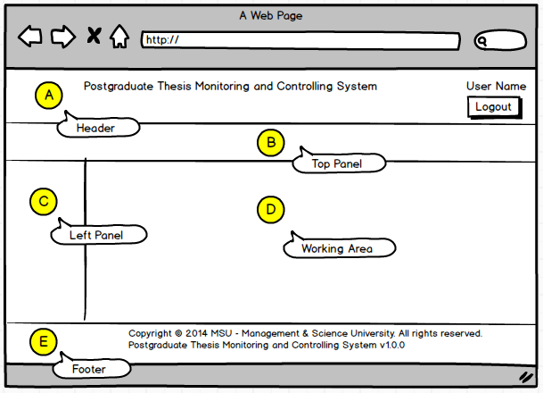

Figure 1: PGTMCS Screen Structure Design

# HIGHLEVEL FLOW

## Thesis Proposal Submission Process Flow

The figure below depicts the highlevel process flow for the thesis proposal submission which cover from the submission until its get approved by the Senate.

The dotted line as shown below is the focus covered in this manual.

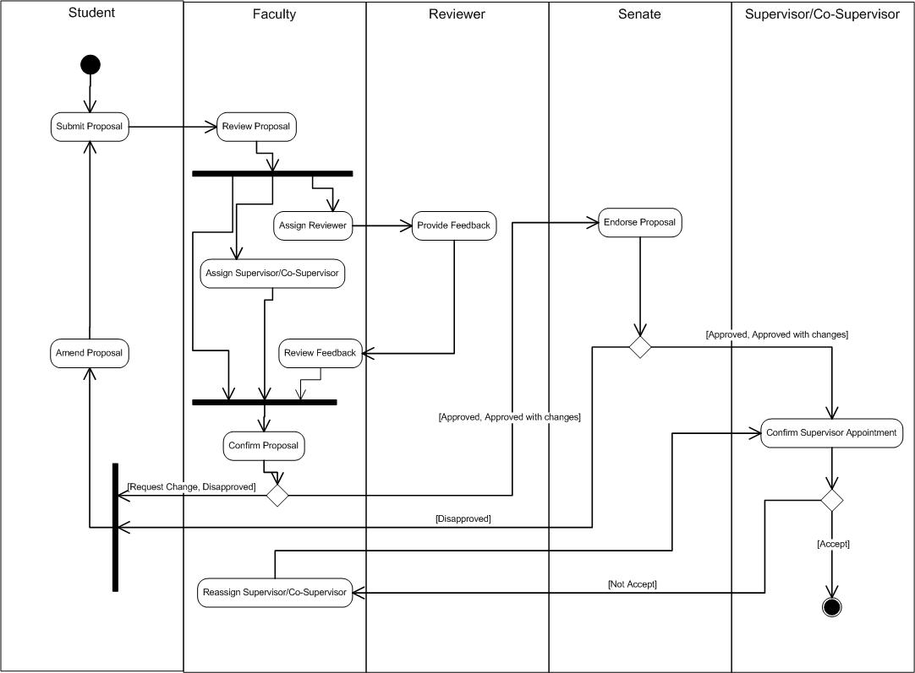

Figure 2: Thesis Proposal Submission Process Flow

# USER LOGIN and LOGOUT

## Login

This is the first page sight by the student to enter the PGTMC system.

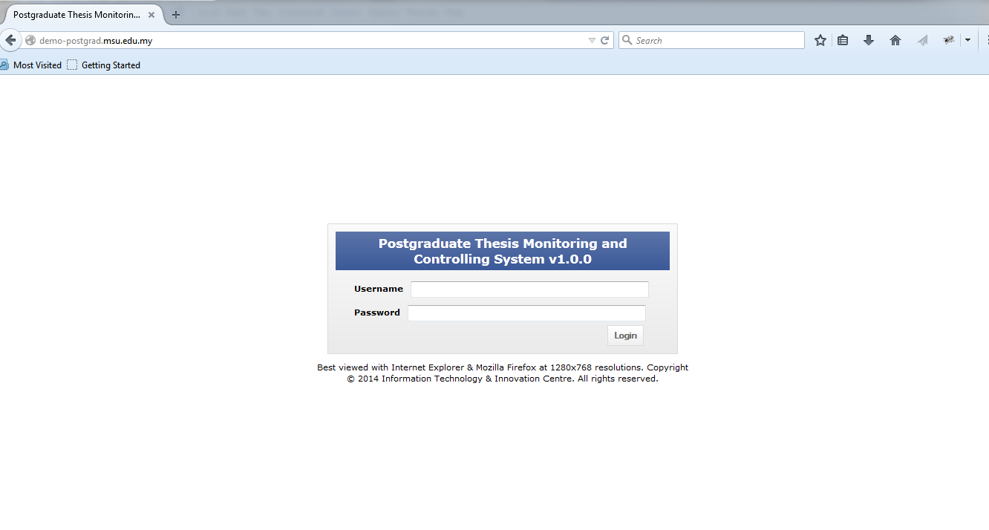

Student need to **login** Postgraduate Thesis System to submit Proposal.

Figure 3: Login Page

**Steps:-**

1. Open any Internet Browser of your choice either Mozilla Firefox or Microsoft Internet Explorer
2. Enter the URL to access the system as follows <http://postgrad.msu.edu.my/>
3. Login page will be displayed in which the valid user credential needs to be provided i.e. **Username** and **Password**.

## Logout

Once the necessary or required activities has been done or completed, the student can quit from the system by clicking on the **Logout** button.

If the system is keep idle for about 1 minute, the system will logged out the user automatically.

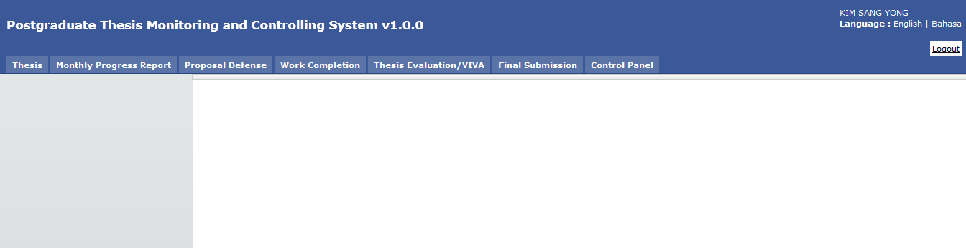

Button **Logout**.

Figure 4: Logout Page

**Steps:-**

1. Find the **Logout** button located on the right top corner of the system **Header** section.
2. Click on it and you will be logout from the system successfully.

# CHANGE PASSWORD

## Change Password

For the security reason, the user is strongly recommended to change the password at first successful login to the system.

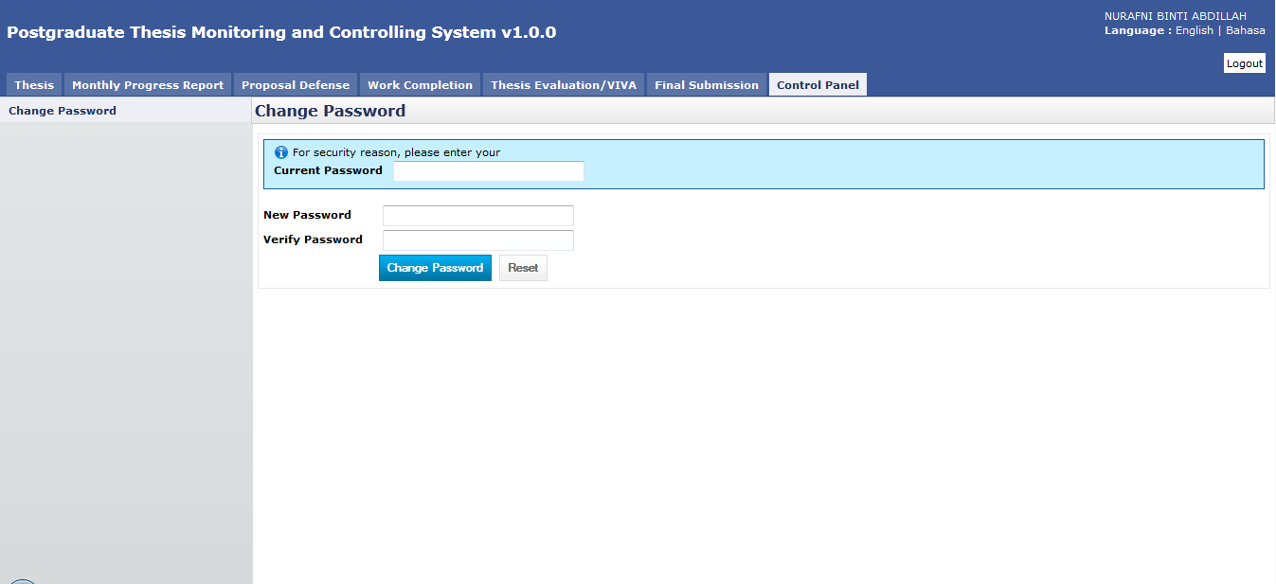

Figure 5: Change Password Page

**Steps:-**

1. Click on the **Control Panel** tab from the system **Top** panel section.
2. The **Change Password** menu will be displayed and click on it.
3. As to ensure the right user able to change the password, the system will ask **Current Password** used before able to change it to the new password.
4. Once the **Current Password** has been provided, the **New Password** and **Verify Password** can be provided afterward.
5. Click **Change Password** button to ensure the new password can be saved into the system successfully.
6. If the **Current Password** is incorrect, the system will prompt an error message and the user needs to redo the same steps above.
7. User can use **Reset** button if wanted to clear the entry on each fields.

# THESIS VIEW

## Search Student via Thesis ID/Title

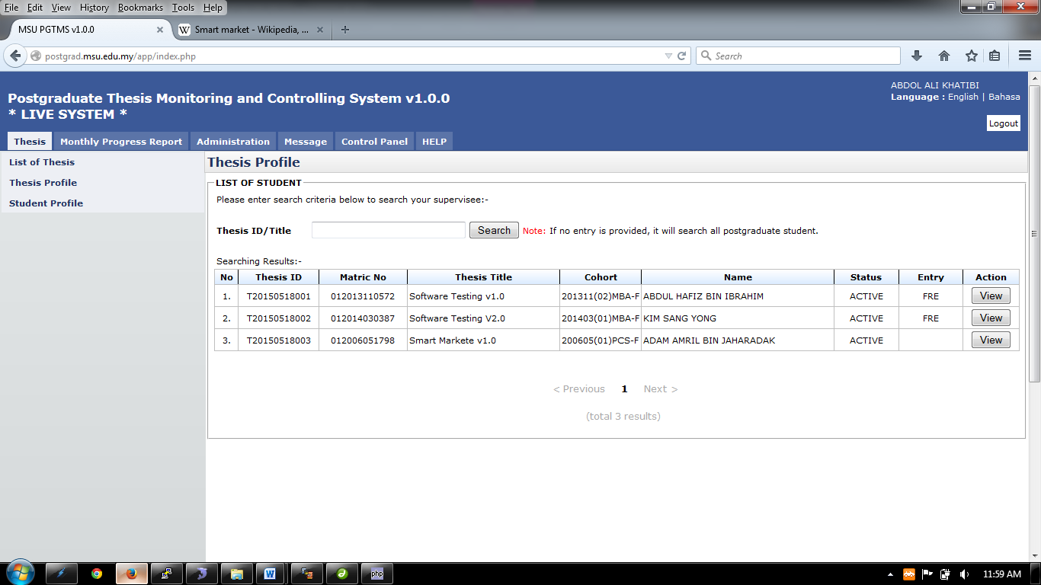Student profile can be retrieved via student’s **Thesis ID or Title**

Figure 6: Thesis Tab

**Pre-condition**

1. none

**Post-condition**

1. View Student Profile

**Steps:-**

1. Click on the **Thesis** tab on the system **Top** panel section.
2. The **Student Profile** menu will be displayed on the system **Left** panel and click on it.
3. The searching page will be displayed which the user can search for a particular thesis in order to view its detail
4. Enter the **Thesis ID** or **Title**. into the field and click on **Search** button to search the thesis
5. The record will be displayed under the search result.
6. Locate the student from the list and click **View** button to view the profile details

### Student Profile Details

Student Profile will contain all information that related to students which are Student Profile, Supervisor/Co-supervisor lists, Subject Taken and Thesis History.

#### Student Profile

Student Profile tab contains the basic student and thesis information including its thesis progress status

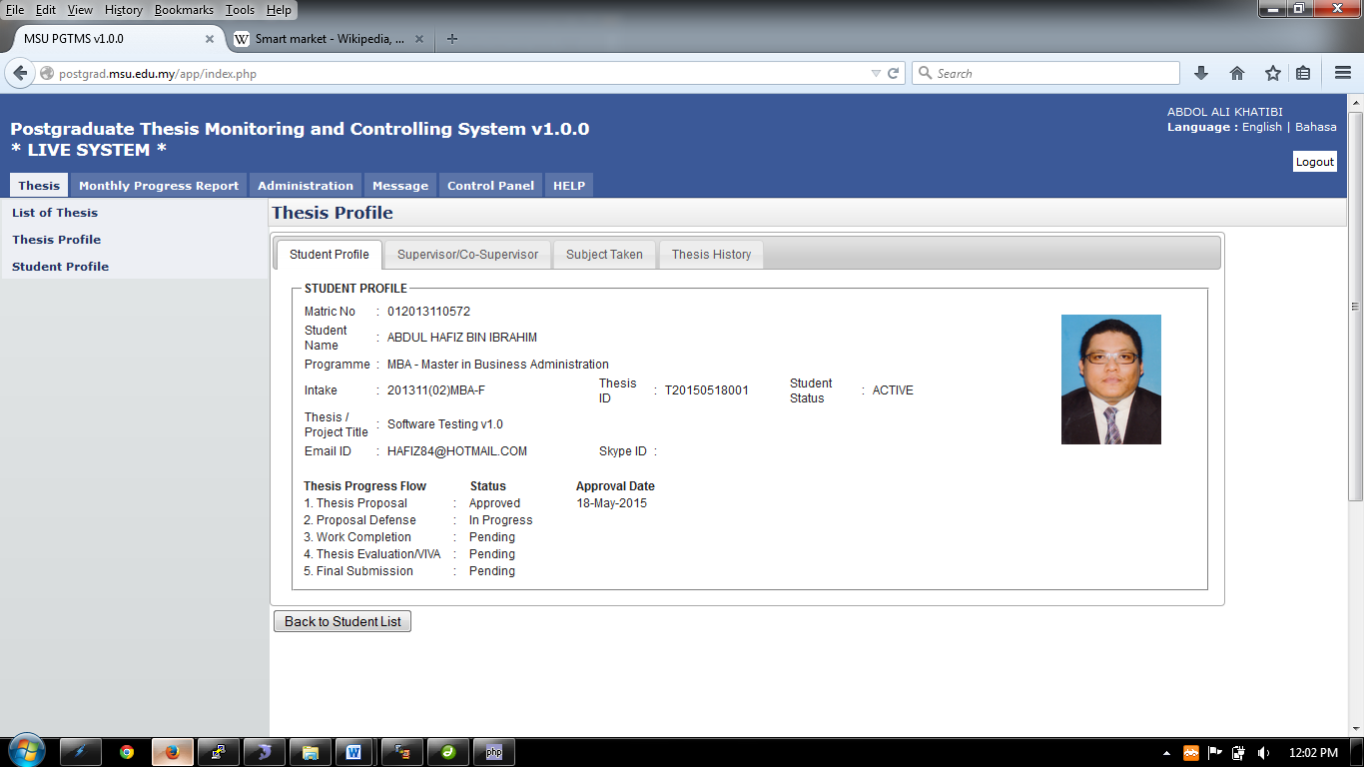

Figure 7: Student Profile Tab

**Steps:-**

1. It is only for view information.
2. Click **Back to Student List** button to return back to **Student List** search page

#### Supervisor/Co-Supervisor List

Supervisor or Co-Supervisor is the academic staff who has been assigned by Faculty to supervise the student in delivering the thesis and approved by the Senate.

There are conditions for the student to see the list of his/her supervisors. The conditions are:-

1. Supervisor/Co-Supervisor has been assigned by Faculty and approved by the Senate
2. Supervisor/Co-Supervisor has accepted the appointment to supervise the student.

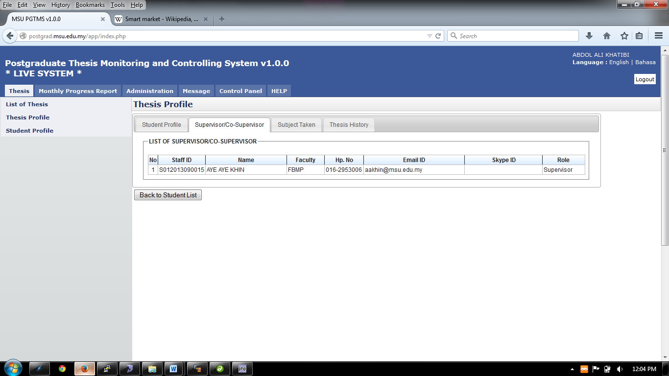

Figure 8: List of Supervisor / Co-Supervisor

**Steps:-**

1. It is only for view information.
2. Click **Back to Student List** button to return back to **Student List** search page

#### Subject Taken

Subject Taken tab will list the entire subject registered by the students for all semester during his study.

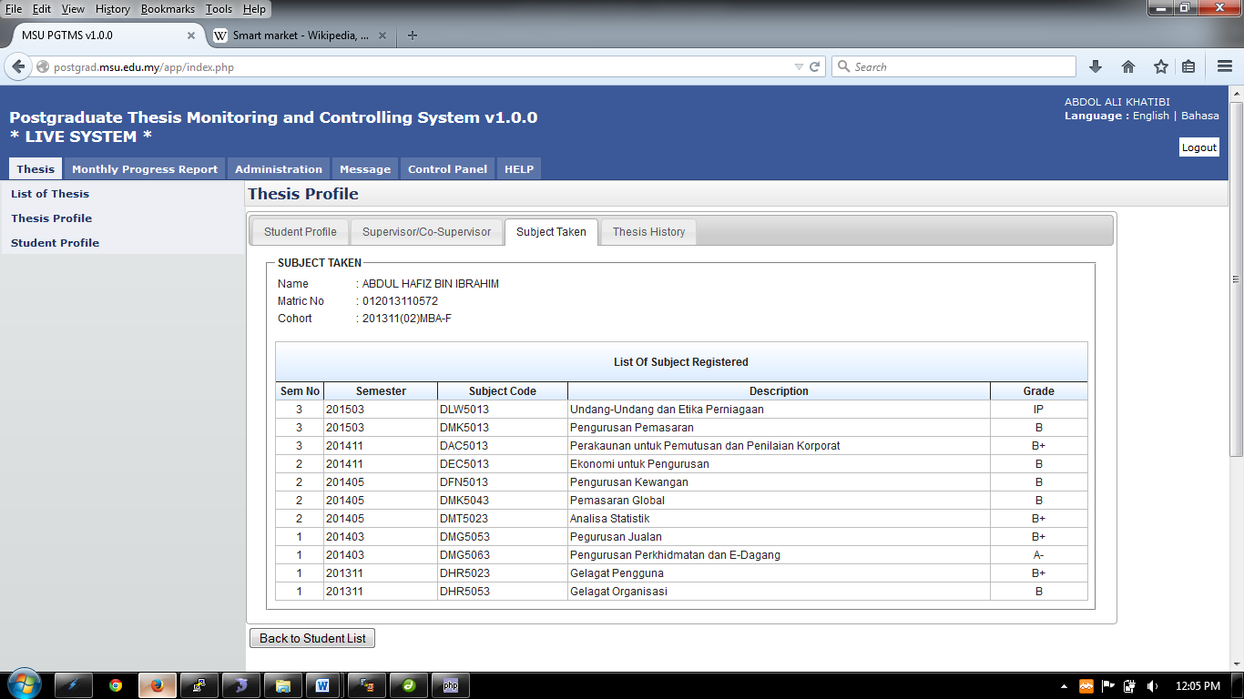

Figure 9: Subject Taken

**Steps:-**

1. It is only for view information.
2. Click **Back to Student List** button to return back to **Student List** search page

#### Thesis History

Thesis History tab contains the proposal progress history starting from its submission by the student untill its approval by the Senate. It captures the date of

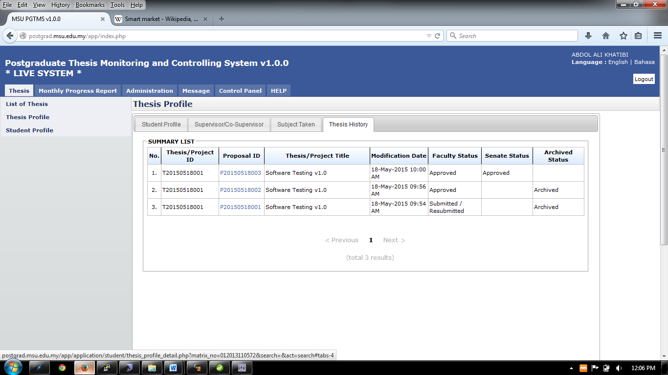

Figure 10: Thesis Tab – Thesis History

**Steps:-**

1. It is only for view information.
2. Click **Back to Student List** button to return back to **Student List** search page

## Search Student via Student Name/Matrix No

Student profile can be retrieved via student’s **Name** or **Matrix Number**.

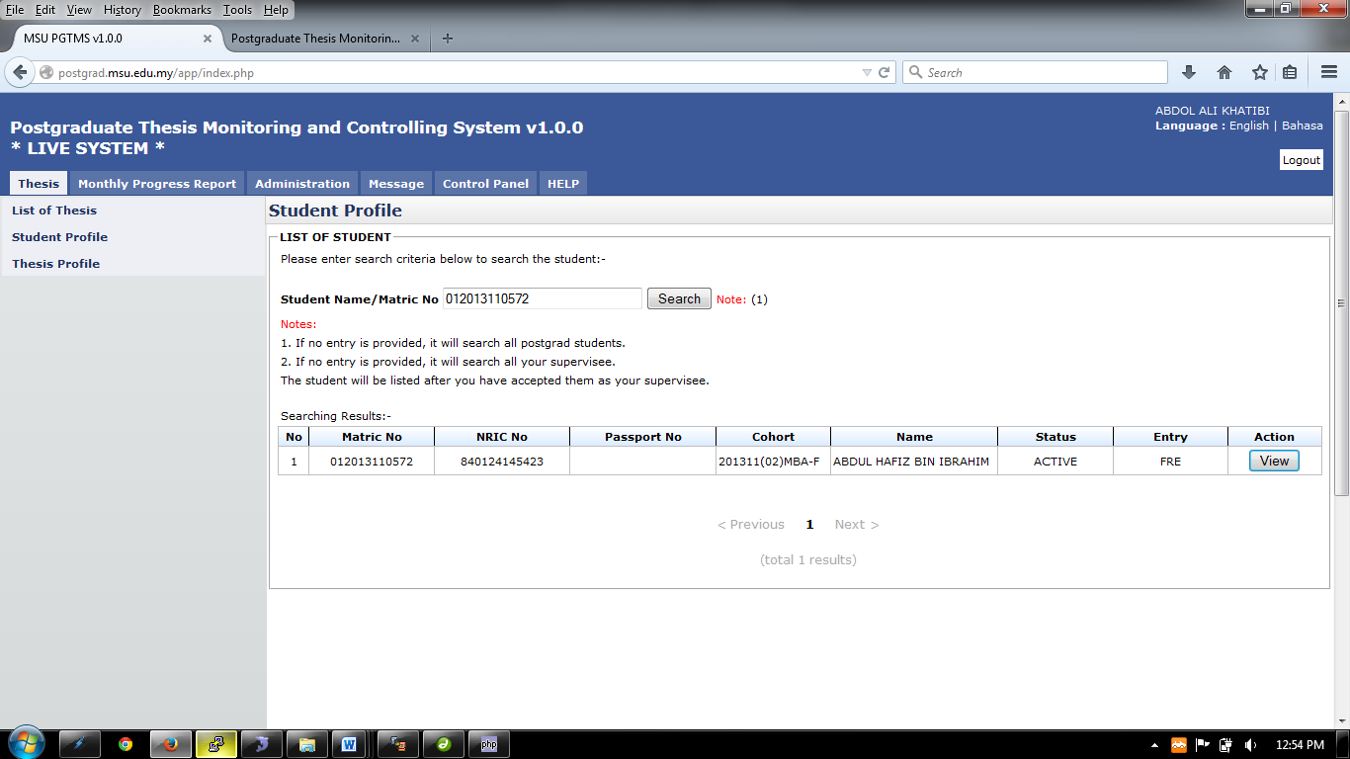

Figure 11: Thesis Tab – List of Student

**Steps:-**

1. Click on the **Thesis** tab on the system **Top** panel section.
2. The **Student Profile** menu will be displayed on the system **Left** panel and click on it.
3. The searching page will be displayed which the user can search for a particular student in order to view its detail
4. Enter the **Student’s Name** or **Matrix No**. into the field and click on **Search** button to search the student
5. The record will be displayed under the search result.
6. Locate the student from the list and click **View** button to view the profile details

### Student Profile Details

Student Profile will contain all information that related to students which are Student Profile, Supervisor/Co-supervisor lists, Subject Taken and Thesis History.

#### Student Profile

Student Profile tab contains the basic student and thesis information including its thesis progress status



Figure 12: Thesis Tab – Student Profile

**Steps:-**

1. It is only for view information.
2. Click **Back to Student List** button to return back to **Student List** search page

#### Supervisor/Co-Supervisor List

Supervisor or Co-Supervisor is the academic staff who has been assigned by Faculty to supervise the student in delivering the thesis and approved by the Senate.

There are conditions for the student to see the list of his/her supervisors. The conditions are:-

1. Supervisor/Co-Supervisor has been assigned by Faculty and approved by the Senate
2. Supervisor/Co-Supervisor has accepted the appointment to supervise the student.

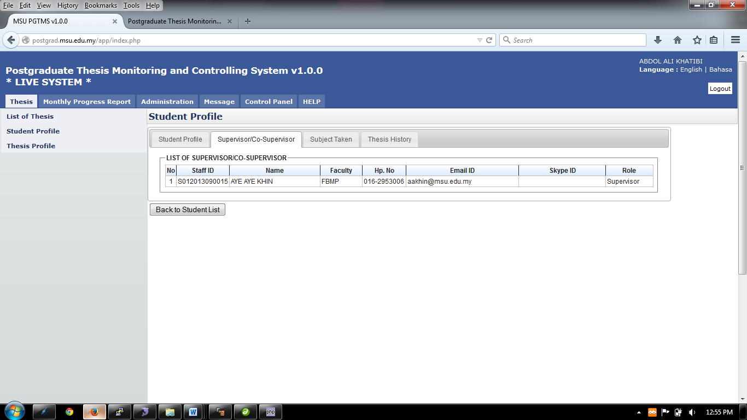

Figure 13: Thesis Tab - List of Supervisor / Co-Supervisor

**Steps:-**

1. It is only for view information.
2. Click **Back to Student List** button to return back to **Student List** search page

#### Subject Taken

Subject Taken tab will list the entire subject registered by the students for all semester during his study.

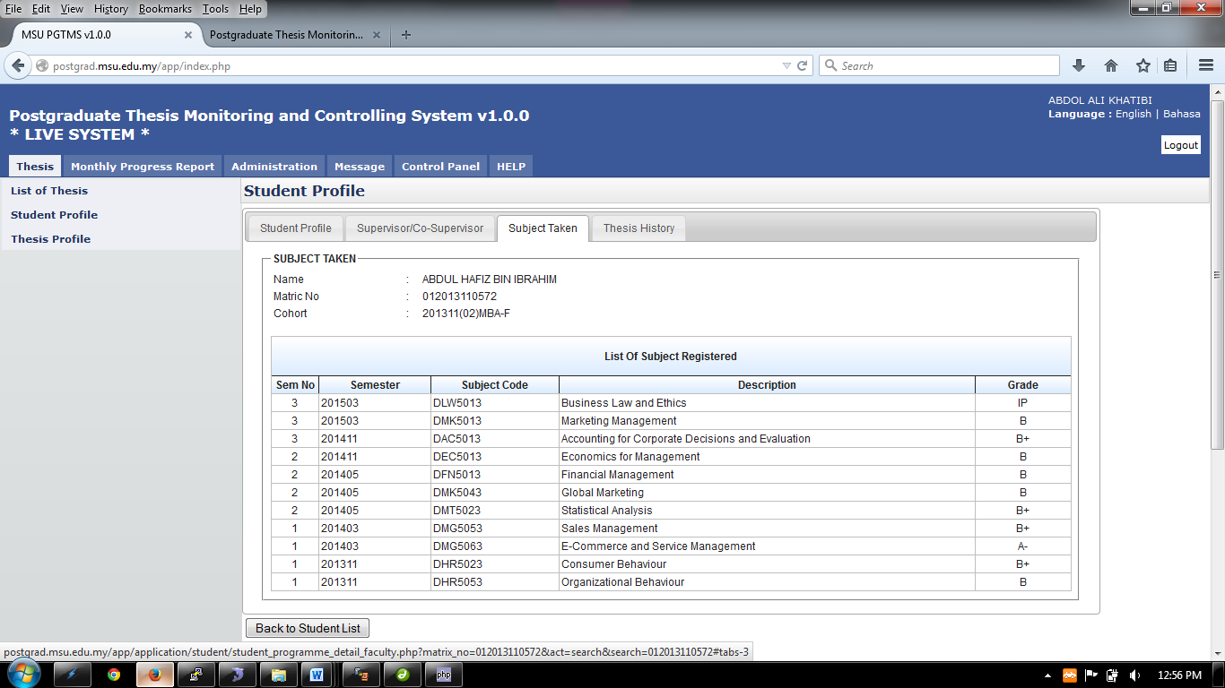

Figure 14: Thesis Tab - Subject Taken

**Steps:-**

1. It is only for view information.
2. Click **Back to Student List** button to return back to **Student List** search page

#### Thesis History

Thesis History tab contains the proposal progress history starting from its submission by the student till its approval by the Senate. It captures the date of

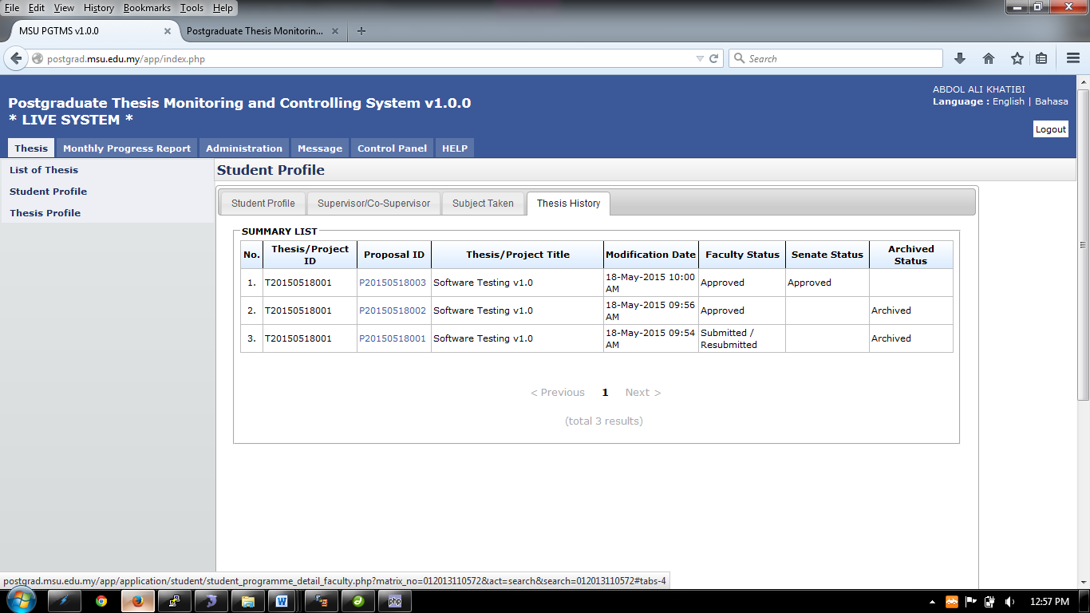

Figure 15: Thesis Tab – Thesis History

**Steps:-**

1. It is only for view information.

# LIST OF APPROVED THESIS

## List of Approved Thesis

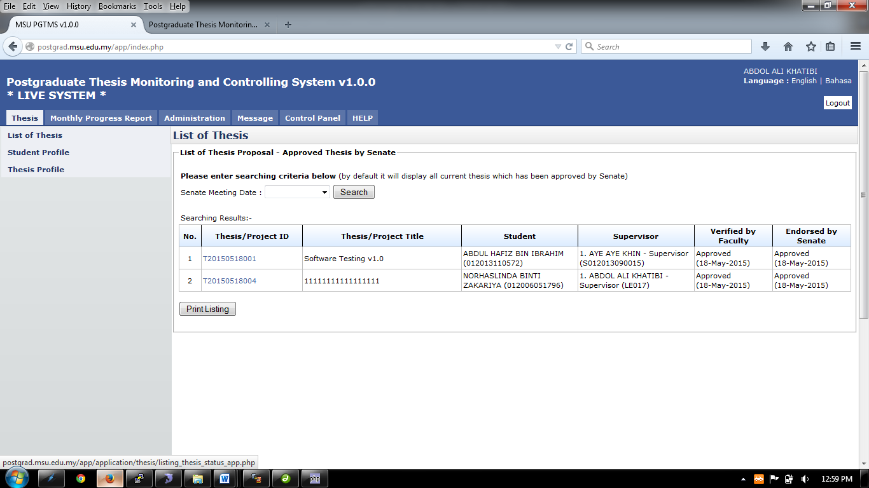

Figure 16: Thesis Tab – List of Thesis

**Pre-condition**

1. Thesis must be approved by senate

**Post-condition**

1. View thesis detail
2. Print listing thesis

**Steps:-**

1. Click on the **Thesis** tab on the system **Top** panel section.
2. The **List of Thesis** menu will be displayed on the system **Left** panel and click on it.
3. The searching page will be displayed which the user can search for a particular thesis that have been approved by the Senate in order to view its detail
4. Select the **Senate Meeting Date** at the field and click on **Search** button to search the thesis
5. The record will be displayed under the search result.
6. To print the detail, click **Print Listing** button to proceed.

## Generate PDF File

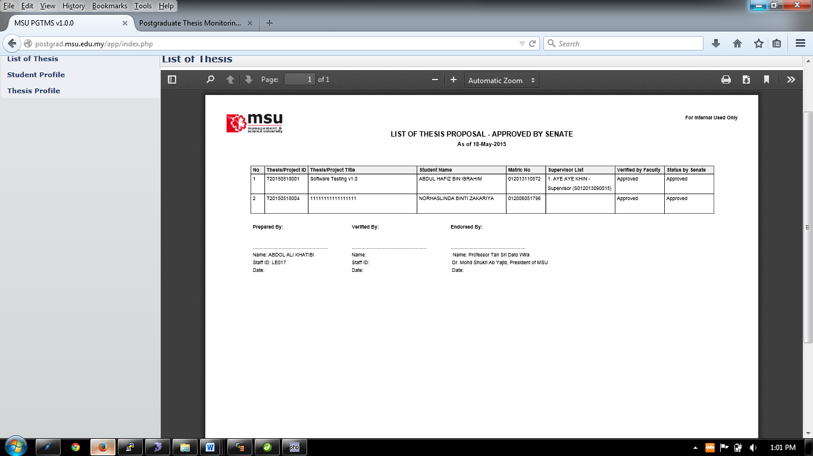

Figure 17: Thesis Tab – List of Thesis PDF

**Steps:-**

1. To print, click the print logo button 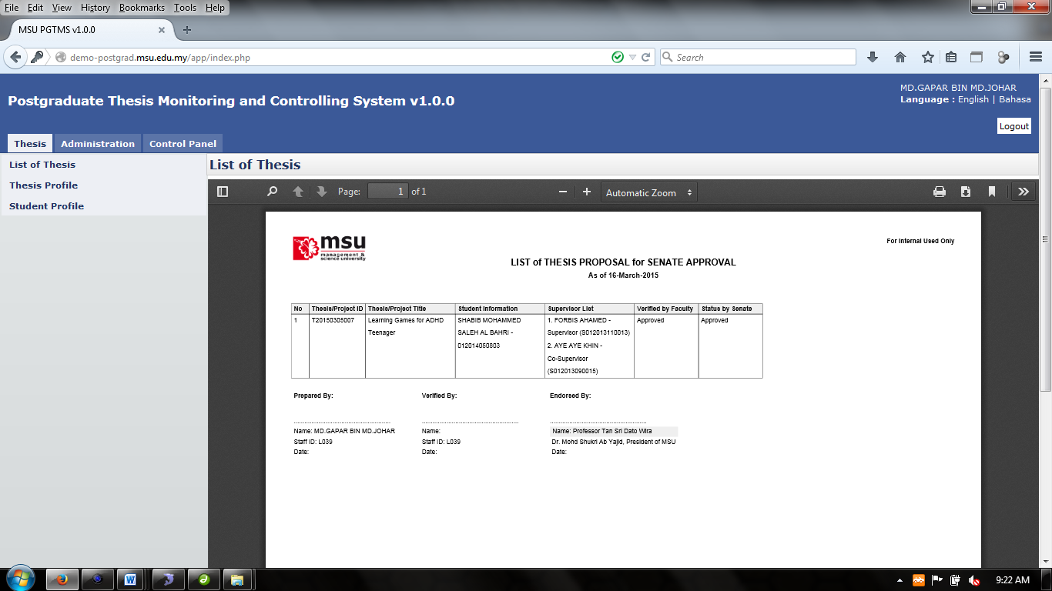 to print.
2. To save file (PDF) click the download logo button 

# ADMINISTRATION VIEW

Administration consist of Reviewer Feedback, Proposal Confirmation, Proposal Cancellation, Assign Supervisor, List of Thesis and Assign Reviewer

## Reviewer Feedback Approval

All process to approve/disapprove, view, assign or cancellation are as listed on the **Left** panel.

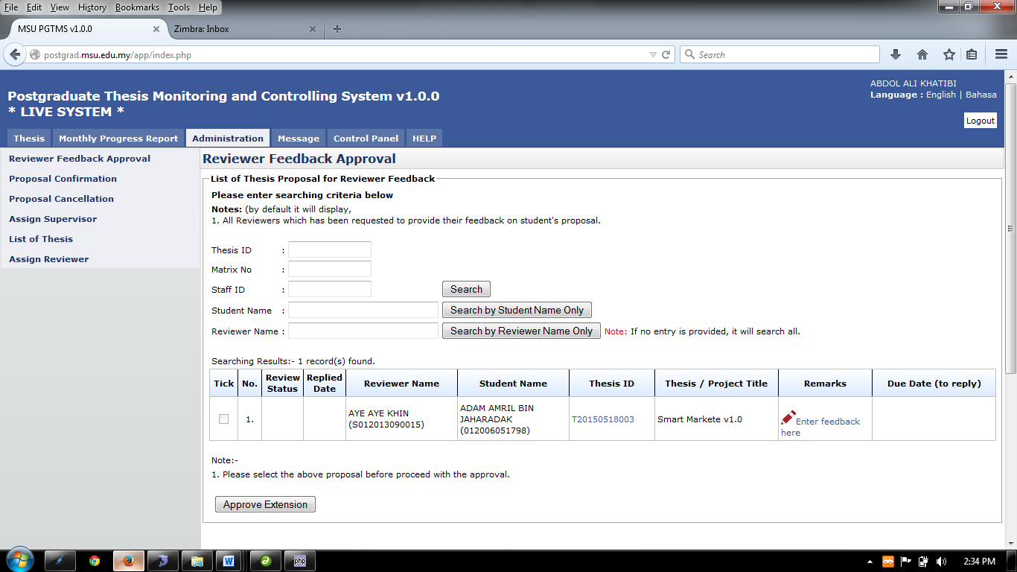

Figure 18: Administration Tab – Reviewer Feedback Approval

**Pre-condition**

1. Thesis that have been reviewed by reviewer

**Post-condition**

1. View remarks by reviewer regarding thesis
2. Proceed to proposal confirmation

**Steps:-**

1. Click on the **Administration** tab on the system **Top** panel section.
2. The **Administration** menu will be displayed on the system **Left** panel and click on it.
3. Click the **Reviewer Feedback Approval** and the searching page will be displayed which the user can search for a particular reviewer to give feedback on it or read the feedback that has been submit by reviewer.
4. Enter the **Thesis’s ID** or **Matrix No** or **Staff ID**. into the field and click on **Search** button to Reviewer Feedback
5. The record will be displayed under the search result.
6. **Or** Reviewer Feedback can be search via **Student Name** or **Reviewer Name** by enter the student name and click **Search by Student Name Only** or enter the reviewer name and click the **Search by Reviewer Name Only**.
7. The record will be displayed under the search result
8. To give the feedback or remarks or read the feedback, click on the link **Enter feedback here** to proceed.

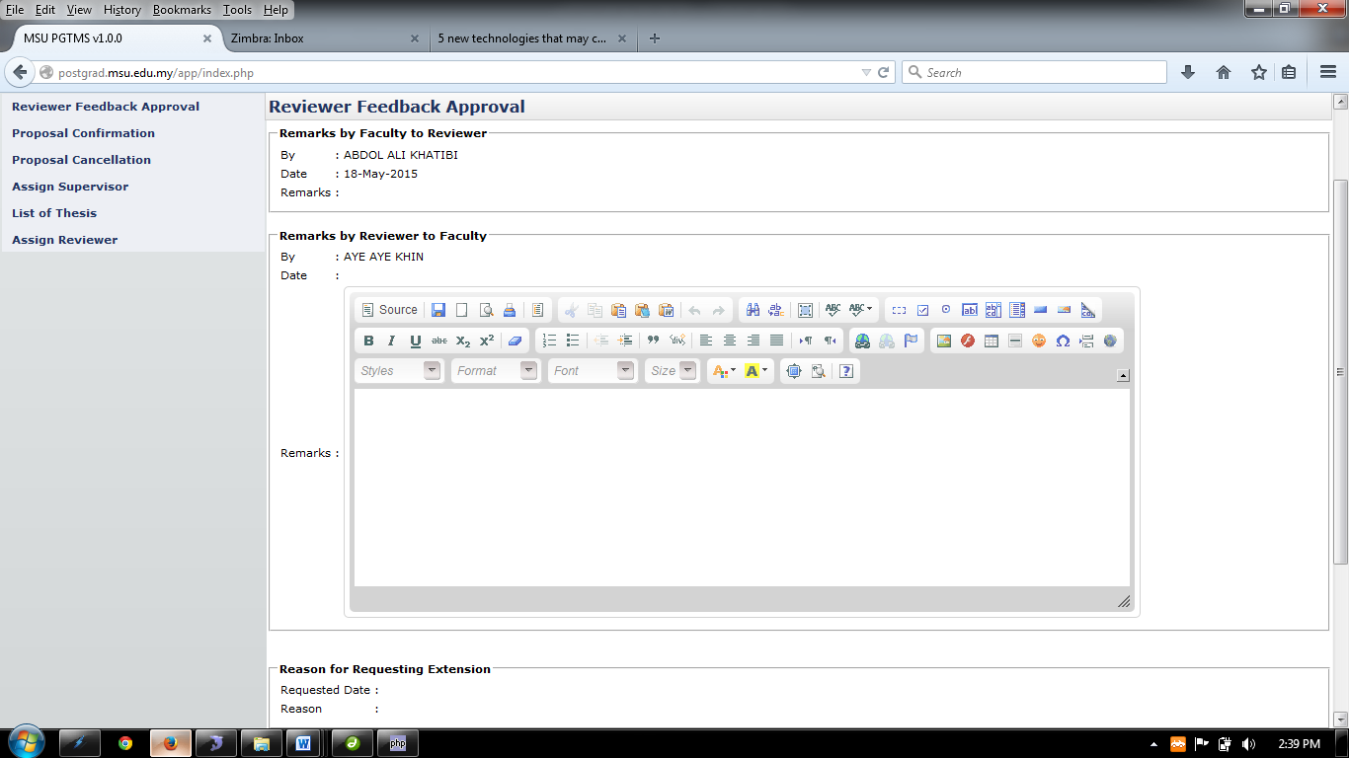

Figure 19: Thesis Tab – Reviewer Feedback Approval (...cont’d)

**Steps:-**

1. After clicking the link **Enter feedback here,** the result will be shown like above.
2. Insert the necessary remark or feedback and click the **Update** button to proceed and click to **Back** button to return to previous page.



Tick the selected result to approve

Figure 20: Administration Tab – Reviewer Feedback Approval search result

**Steps:-**

1. **Tick** the selected result to approve the extension then **Click** the **Approve Extension** button to proceed.

## Proposal Confirmation List

Proposal Confirmation page will list all the thesis proposal that being proposed by the Student to the Faculty for review and approval decision. At this stage the Faculty can also recommend the right Supervisor / Co-supervisor to supervise the student on their thesis including the Reviewer.

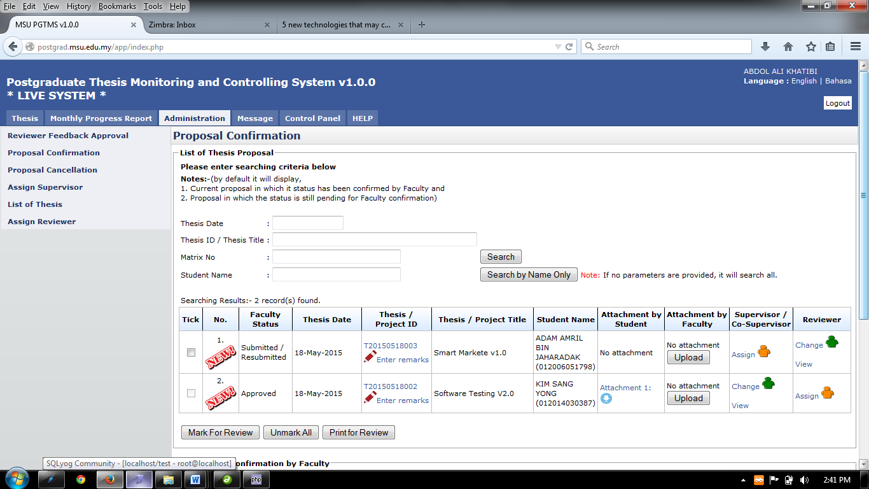

Figure 21: Administration Tab – Proposal Confirmation

**Pre-condition**

1. List of thesis proposal submit by student

**Post-condition**

1. Wait for reviewer to review the thesis
2. Wait for new thesis proposal submit by student
3. Wait for senate approval.

**Steps:-**

1. Click on the **Administration** tab on the system **Top** panel section.
2. The **Administration** menu will be displayed on the system **Left** panel and click on it.
3. Click the **Proposal Confirmation** and the searching page will be displayed which the user can search for a particular thesis to manage it. Otherwise, the result will show all the thesis.
4. The searching criteria can be entered individually or by combination as shown by field below
   1. **Thesis ID**
   2. **Matrix No**
   3. **Thesis Date**
5. Click on the **Search** button to get the search result.
6. Alternatively the search can be done via **Student Name** by entering the student name and click **Search by Student Name Only**.

### Manage Proposal Confirmation

Click here to assign supervisor/co-supervisor

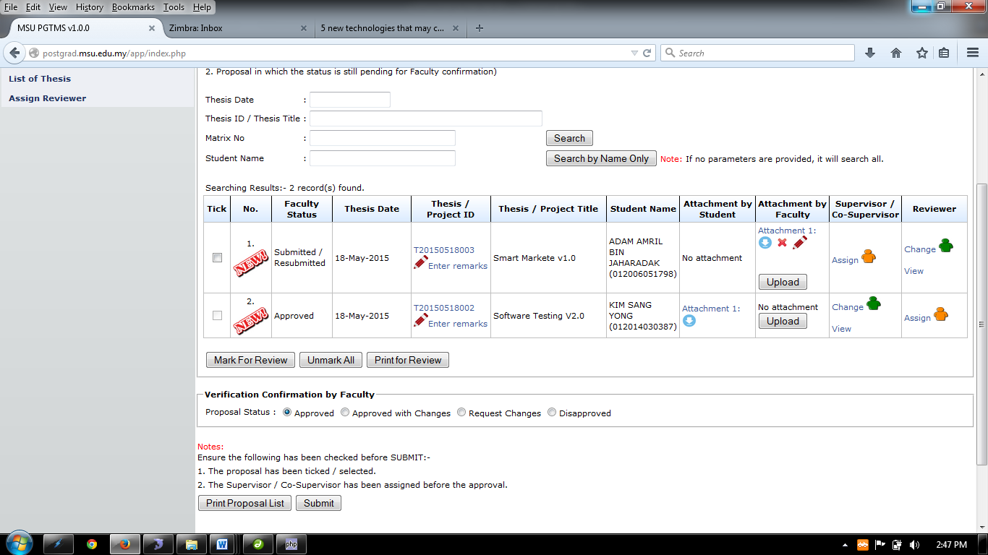

Mark For Review is to mark the thesis proposal for internal review.

Click here to Change or View Reviewer

Click here to assign Reviewer

Click here to Change or View Supervisor/Co-Supervior

Figure 22: Administration Tab – Proposal Confirmation Searching Result

**Steps:-**

1. The result display all the thesis/proposal that been requested by student whether it has been decided or not.
2. The result will show whether the thesis/proposal are new or not by displaying 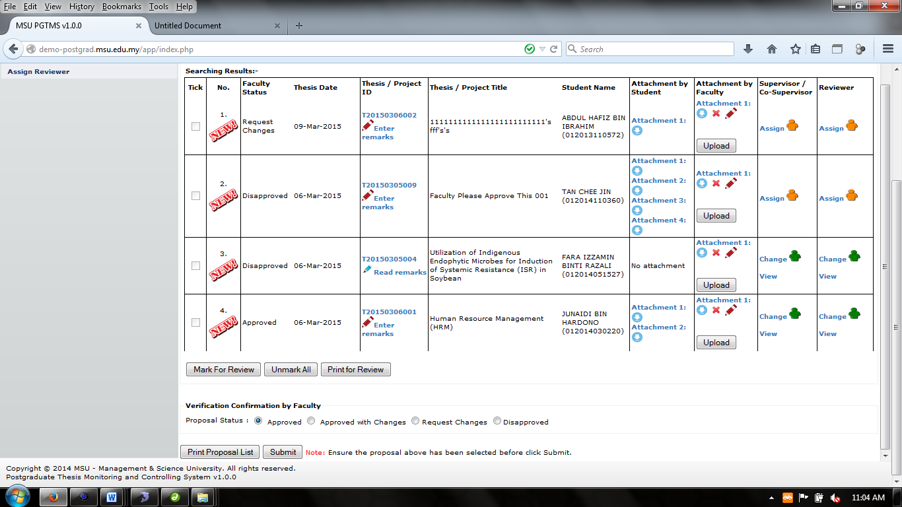 at the **No.** column.
3. To enter remark, click 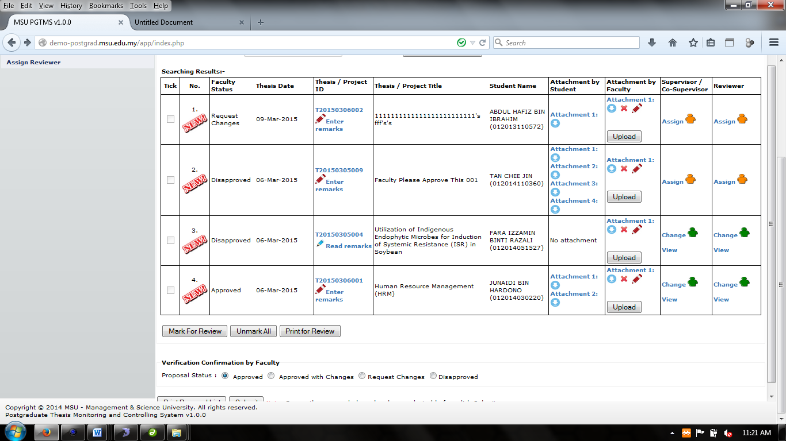that has been displayed.
4. To read remark, click. (Notes: the read remark will be display when the remark already been save in the system)
5. Step 3 and 4 look at **6.2.1.1 Remarks**.
6. To read or download attachment uploaded by student is by click the 
7. To upload the attachment to the system is by click the **Upload** button on the **Attachment by faculty** column.
8. To delete attachment that been upload, click button.
9. To edit description of the file/attachment uploaded, click  button (Look at **6.2.1.2 Edit Attachment Detail**)
10. To assign Supervisor/Co-Supervisor Click  at **Supervisor/Co-Supervisor** column. (Look at **6.2.1.3 Assign Supervisor/Co-Supervisor**)
11. To view the assigned staff, click . (Look at **6.2.1.4 View Assigned Supervisor/Co-Supervisor**)
12. To change the assigned staff, click . (Look at **6.2.1.5 Change Assigned Supervisor/Co-Supervisor**)
13. To assign Reviewer Click  at **Reviewer** column. (Look at **6.2.1.6 Assign Reviewer**)
14. To view the assigned reviewer, click . (Look at **6.2.1.7 View Assigned Reviewer**)
15. To change the assigned Reviewer, click . (Look at **6.2.1.8 Change Assigned Reviewer**)

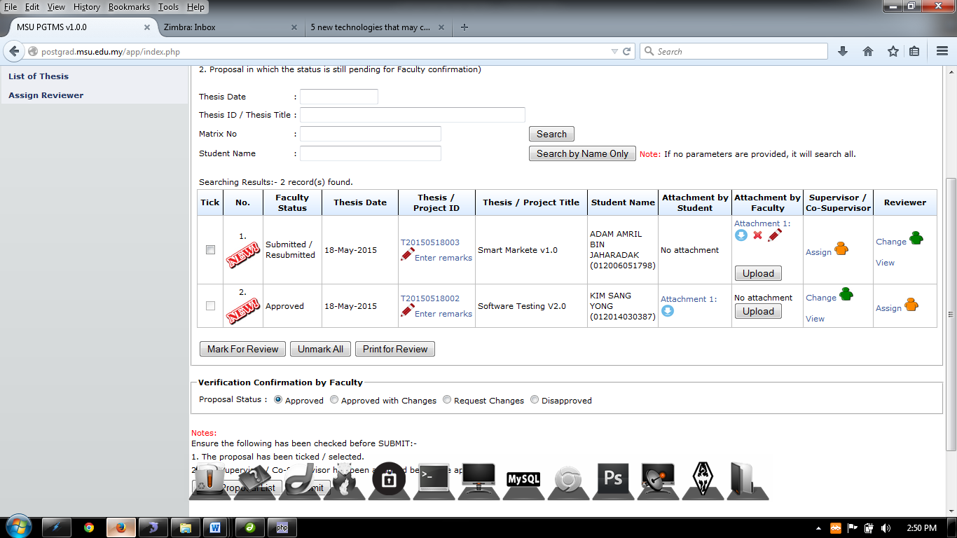

Figure 6.3

This shows that the proposal is pending decision by the Faculty.

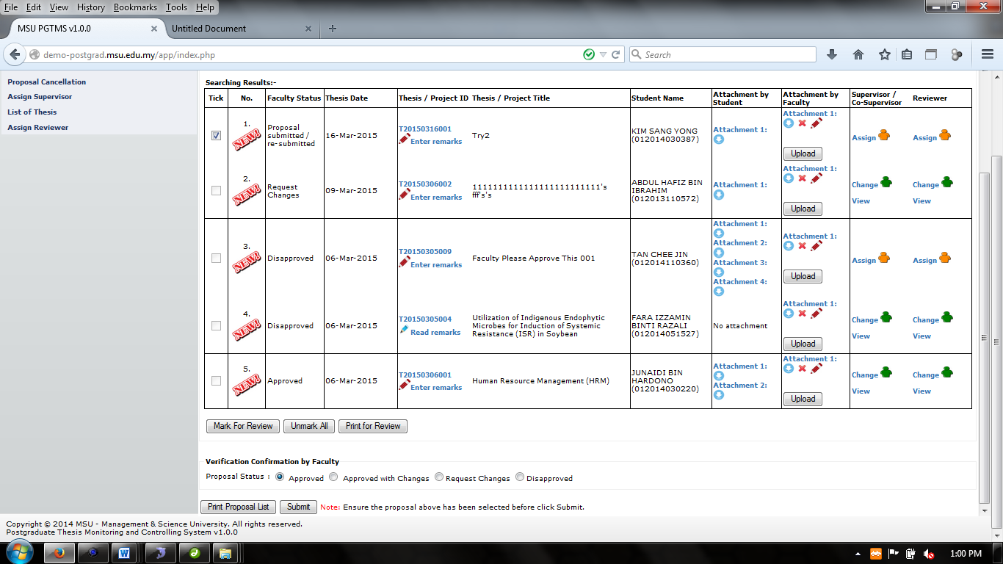

Figure 23: Administration Tab – Proposal Confirmation Status

1. To verify the confirmation of proposal is tick the proposal and by choose the list menu shown at Figure 6.4 which is **Approved, Approved with Changes, Request Changes** or **Disapprove**
2. Then click the **Submit** button to proceed.
3. If the proposal status chosen is **Request Changes** or **Disapproved,** after **Submit** buttonis clicked, the email notification will be sent to the student by the system (Refer Appendix)
4. To print the proposal list, click **Print Proposal List.**

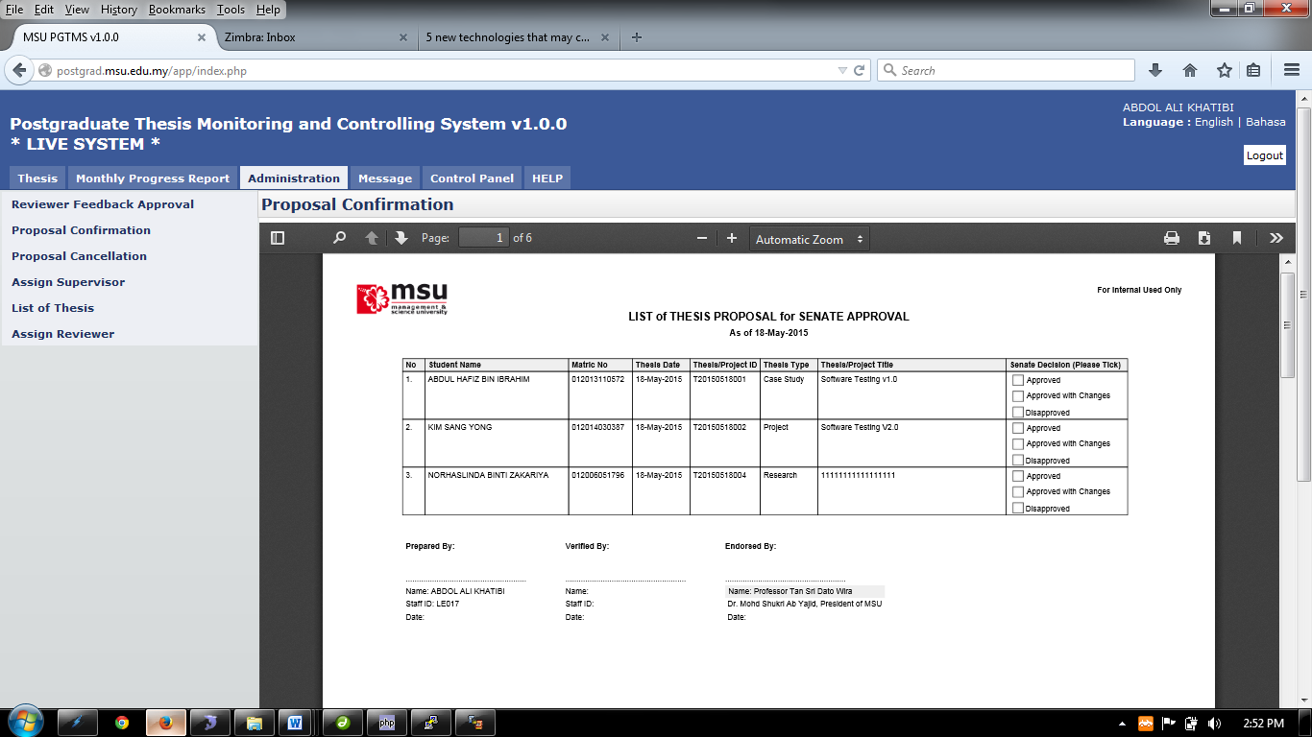

Figure 24: Administration Tab – List of Thesis Proposal for Senate Approval

**Steps:-**

1. To print, click the print logo button  to print.
2. To save file (PDF) click the download logo button.

#### Remarks

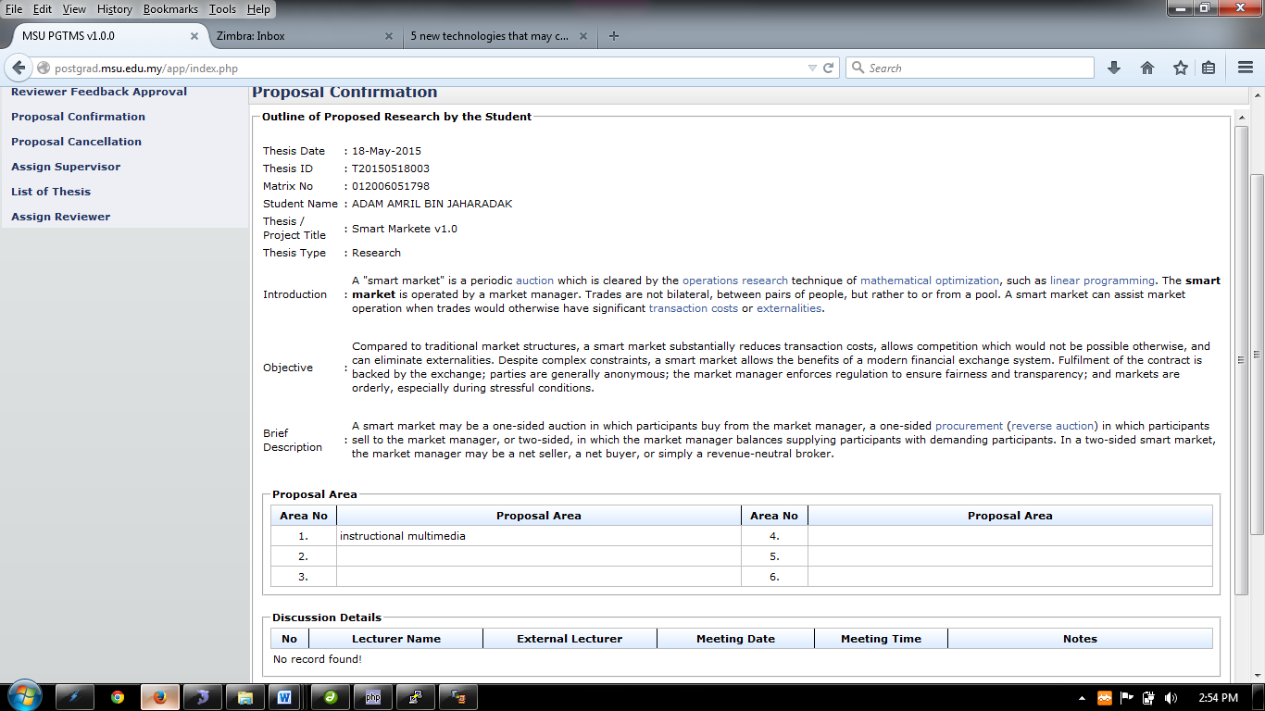

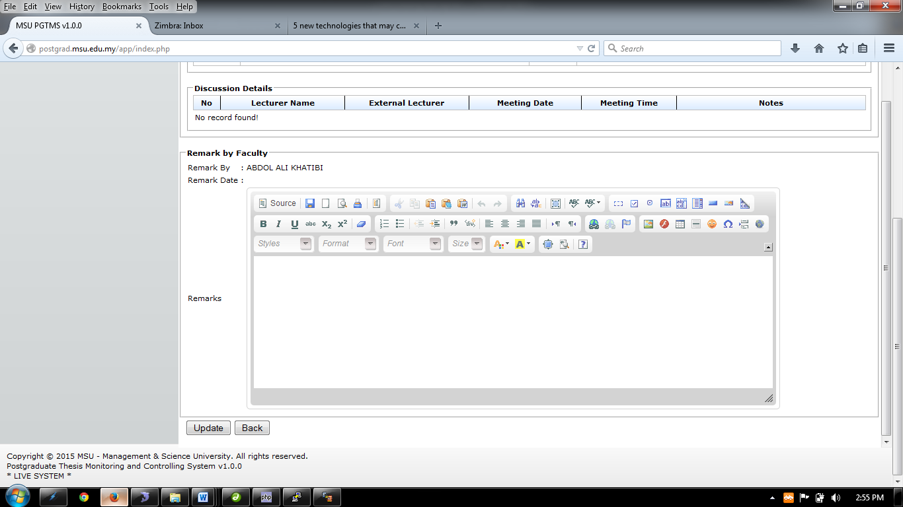

Insert Remarks here

Figure 25: Administration Tab – Proposal Confirmation Remark

**Steps:-**

1. Insert necessary description into the **Remarks** and then click **Update** button
2. Then click **Back** button.

#### Edit Attachment Details

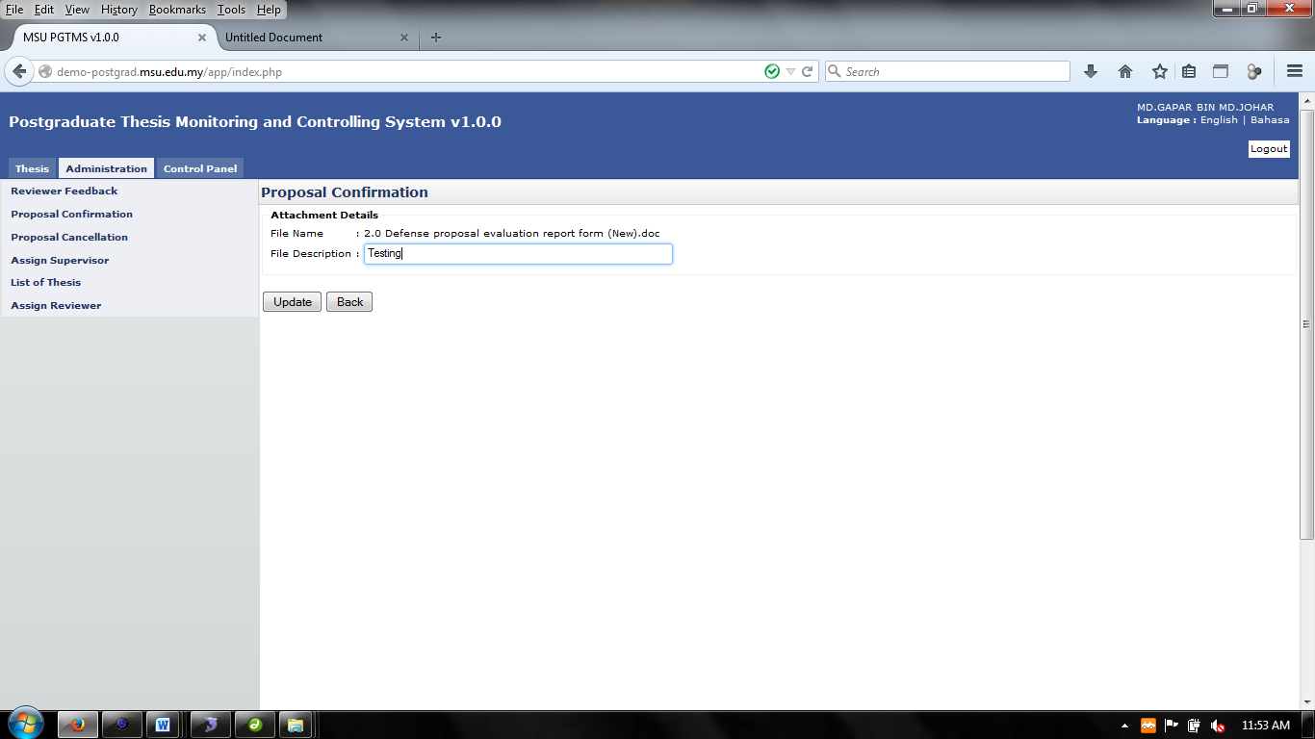

Figure 26: Proposal Confirmation – Edit Description of Attachment

**Steps:-**

1. Insert necessary description into the **File Description** and then click **Update** button
2. Then click **Back** button.

#### Assign Supervisor/Co-Supervisor

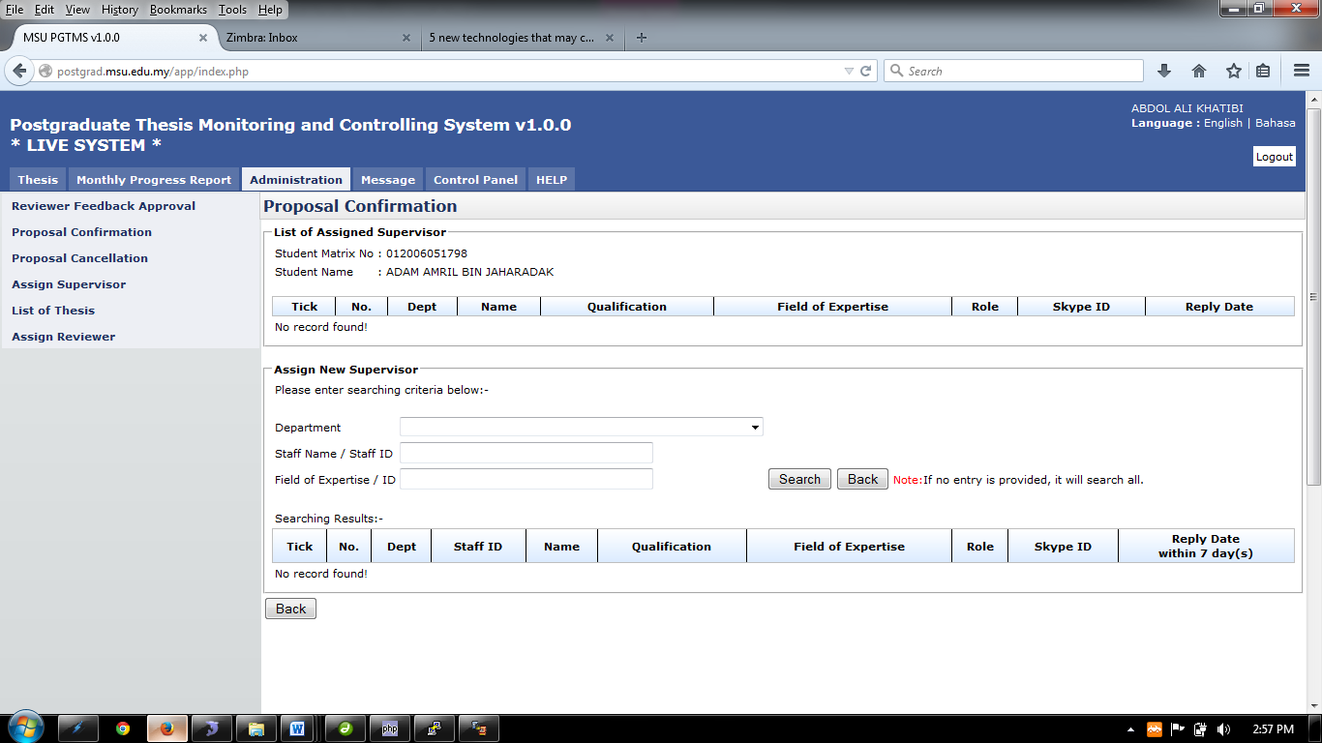

Figure 27: Proposal Confirmation – Assign Supervisor Page

**Steps:-**

1. Choose the department of the supervisor on **Department**, enter the **Staff Name/Staff ID** and **Field of Expertise** and then click the **Search** button to search.
2. If there is no entry provided, the search will display all the staff. (Look at Figure 6.8)
3. Next Step is on the next page

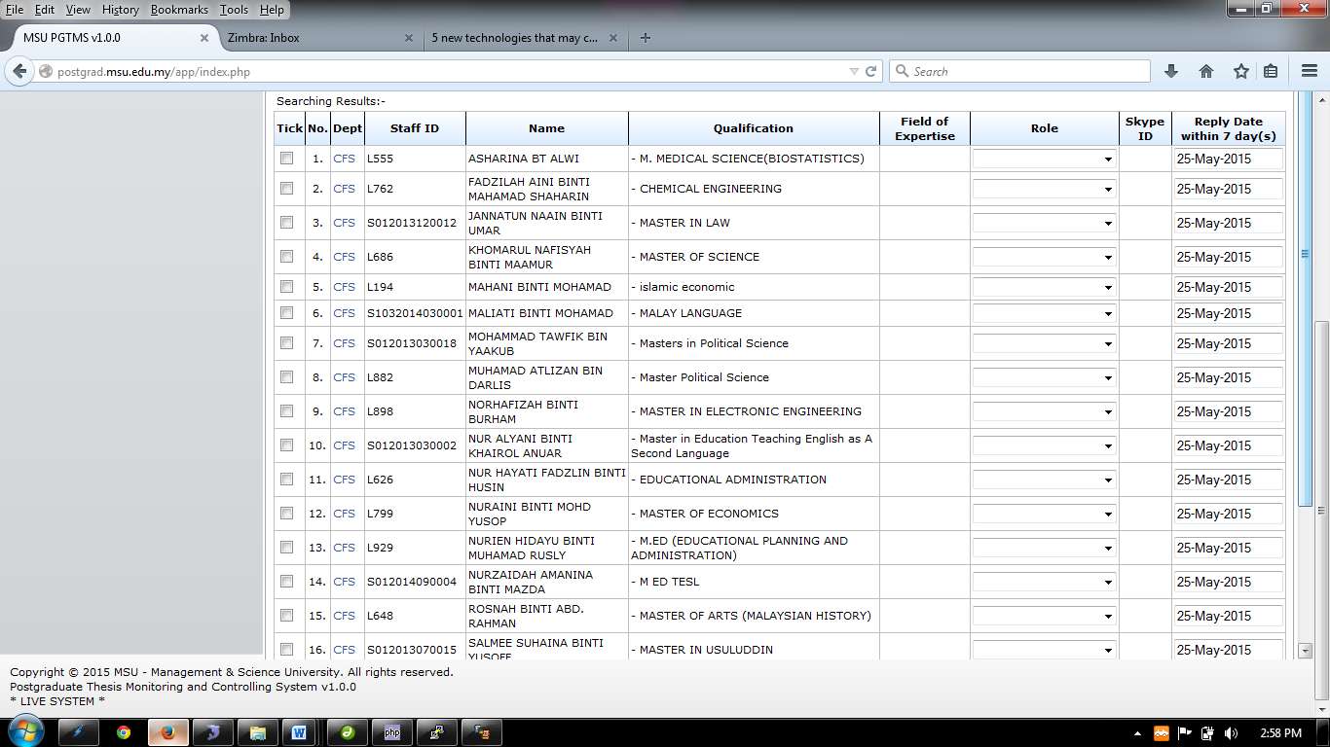

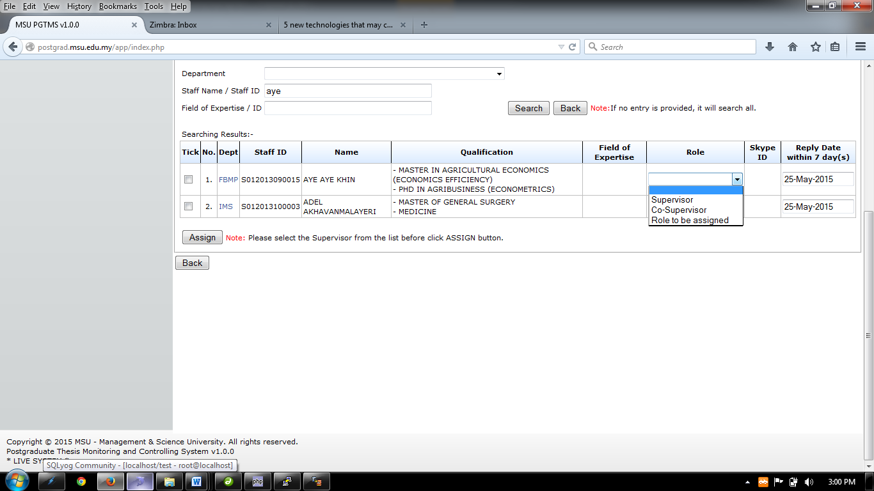

Figure 28: Proposal Confirmation – Search and Assign Supervisor

1. Choose the staff that the user want to assign by ticking the checkbox.
2. Then choose the role of the assigned staff whether to be Supervisor & Co-Supervisor. Then choose the **Reply Date**
3. After the entire step done, click **Assign** button.
4. Then click **Back** button.

#### View Assigned Supervisor/Co-Supervisor

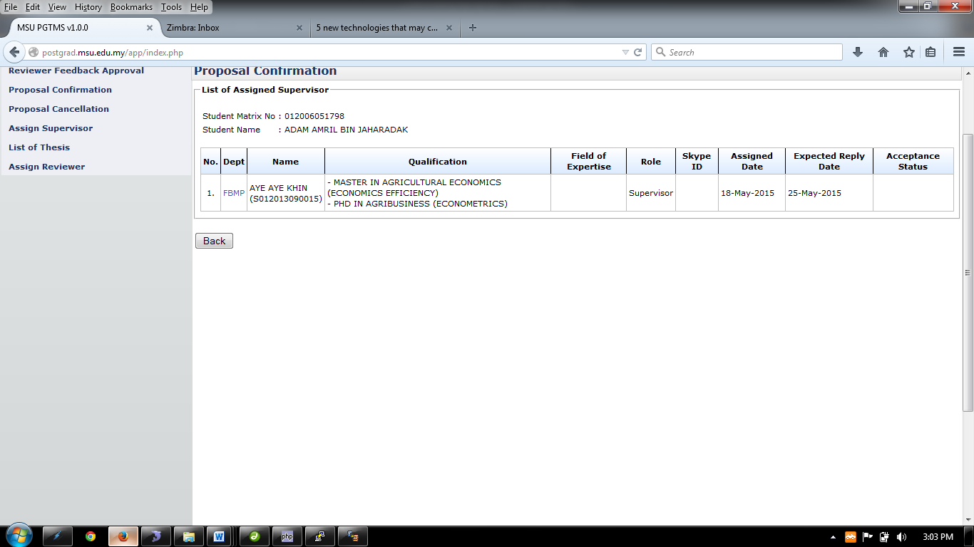

Figure 29: Proposal Confirmation – View Assigned Supervisor/Co-Supervisor

**Steps:-**

1. This page only displays the assigned supervisor/co-supervisor.
2. Then click **Back** button.

#### Change Assign Supervisor/Co-Supervisor

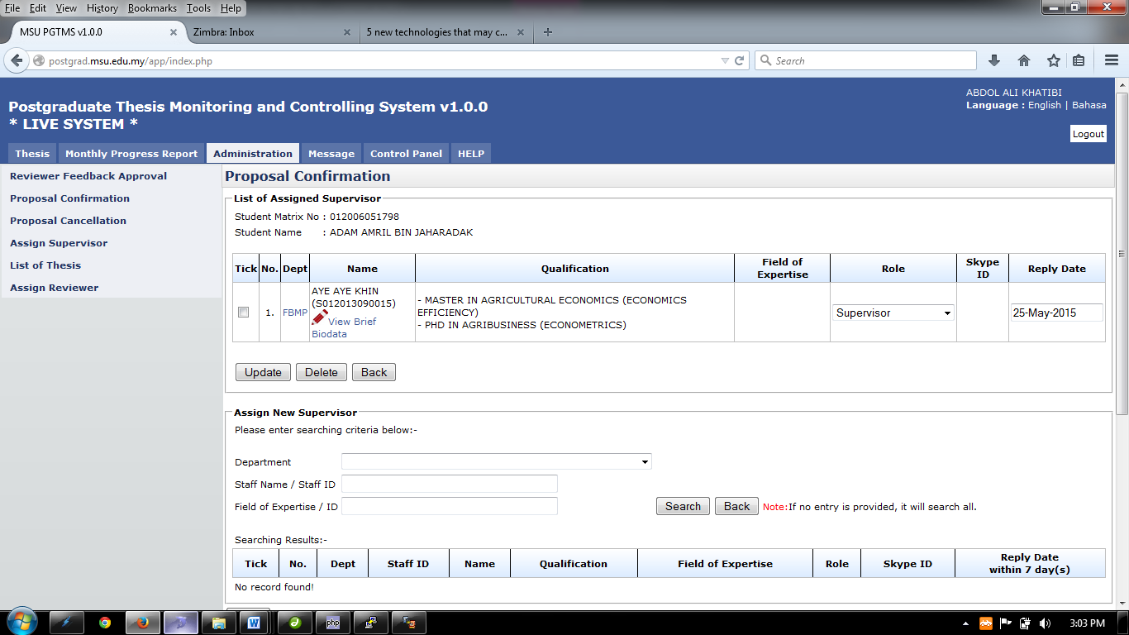

Figure 30: Proposal Confirmation – Change Supervisor/Co-Supervisor

**Steps:-**

1. To assign new Supervisor/Co-supervisor. Choose the department of the supervisor on **Department**, enter the **Staff Name/Staff** and then click the **Search** button to search.
2. If there is no entry provided, the search will display all the staff.
3. Next Step is on the next page



Figure 31: Proposal Confirmation – List All Staffs (If no search criteria is provided)

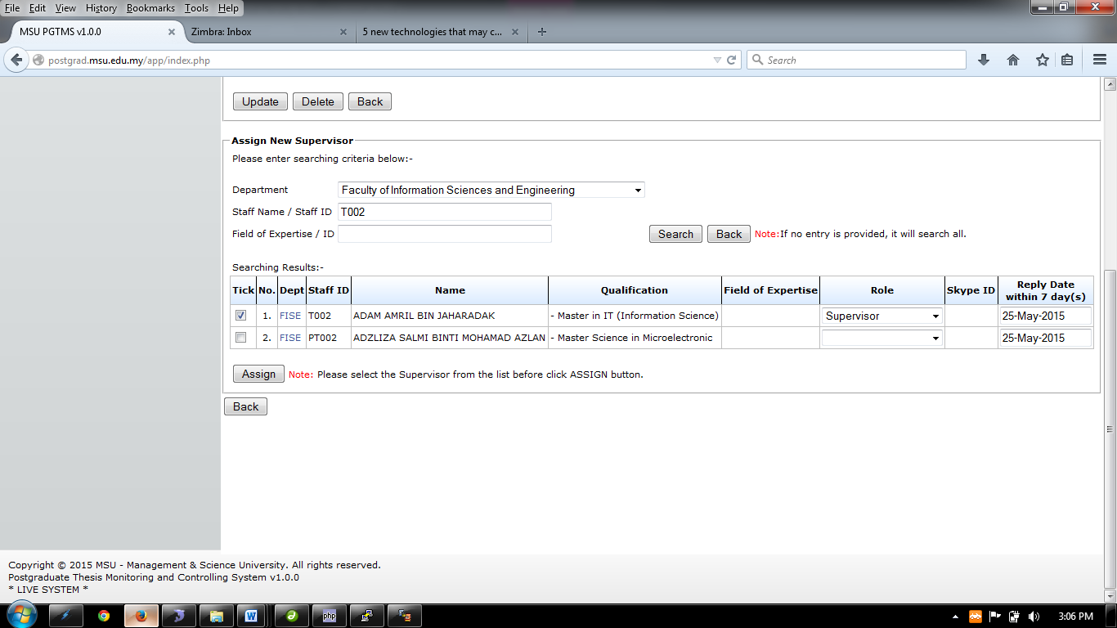

Figure 32: Proposal Confirmation – List the Selected Staff (based on provided search criteria)

1. Choose the staff that the user wants to assign by ticking the checkbox.
2. Then choose the role of the assigned staff whether to be Supervisor, Co-Supervisor, Internal Examiner, and External Examiner.
3. Then choose the **Reply Date**
4. After the entire step done, click **Assign** button.
5. Then click **Back** button.
6. Tick the Staff detail and click **Delete** button to remove the assigned supervisor/co-supervisor
7. To View brief biodata of the staff click. (Look at 6.2.1.5.**1 View Brief Biodata**)
8. To change the role, choose the **Role** listed.
9. Then click **Update** button.

##### View Brief Biodata

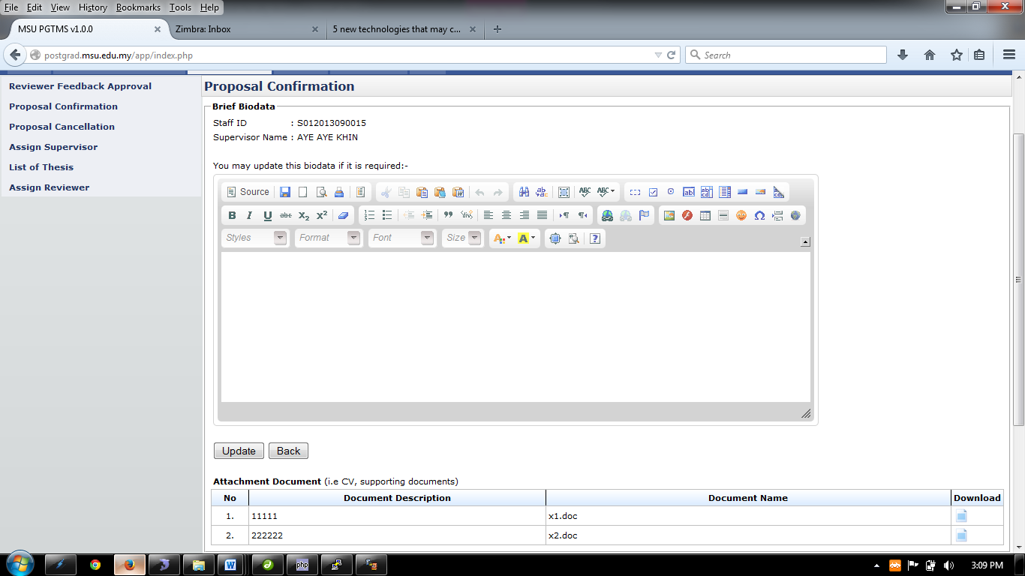

Figure 33: Proposal Confirmation – View and Edit Supervisor/Co-Supervisor Biodata

**Steps:-**

1. Insert necessary description into the **Biodata** and then click **Update** button
2. To download necessary document such as supporting document, click  to download.
3. Then click **Back** button.

#### Assign Reviewer

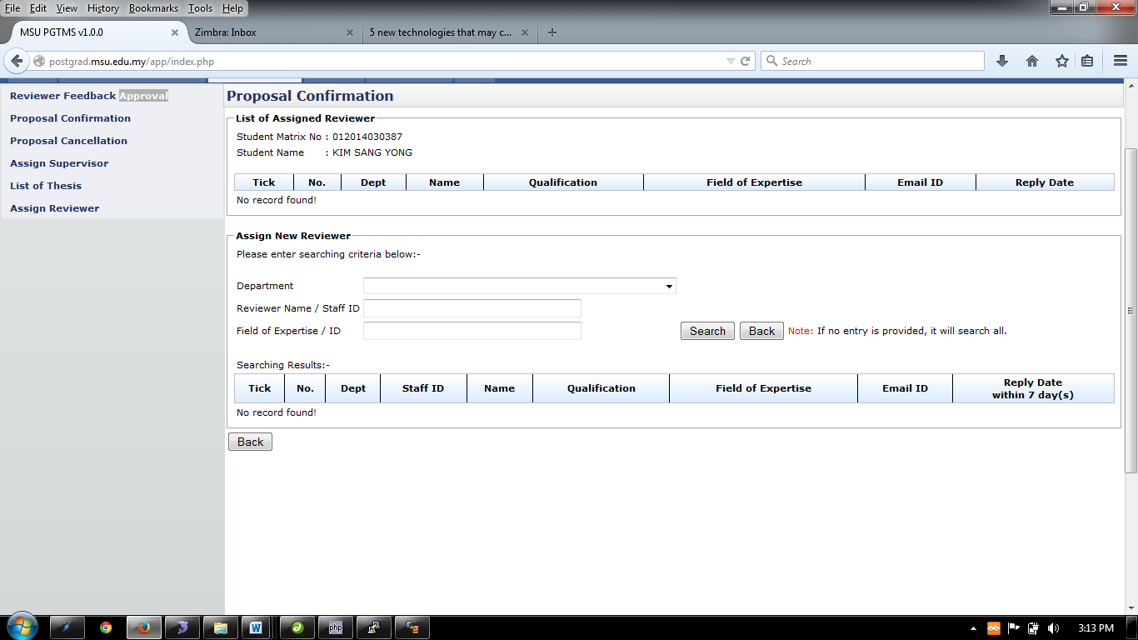

Figure 34: Proposal Confirmation – Assign Reviewer

**Steps:-**

1. Choose the department of the reviewer on **Department**, enter the **Staff Name/Staff ID** and **Field of Expertise** and then click the **Search** button to search.
2. If there is no entry provided, the search will display all the staff. (Look at Figure 7.6)
3. Next Step is on the next page

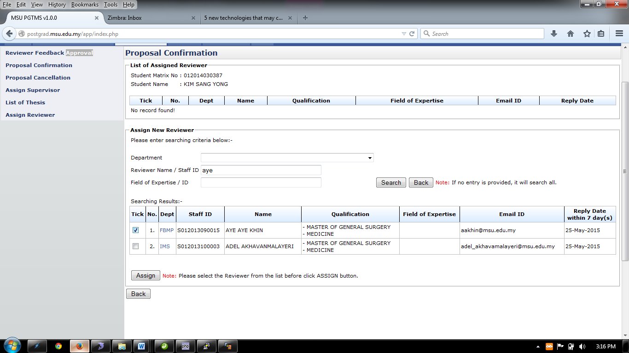

Figure 35: Proposal Confirmation – Assign Reviewer Search Result

1. Choose the staff that the user wants to assign by ticking the checkbox.
2. By default, reply date will be set to 7 days starting the day that been assign.
3. After all the step done, click **Assign** button.
4. Then click **Back** button.

#### View Assigned Reviewer

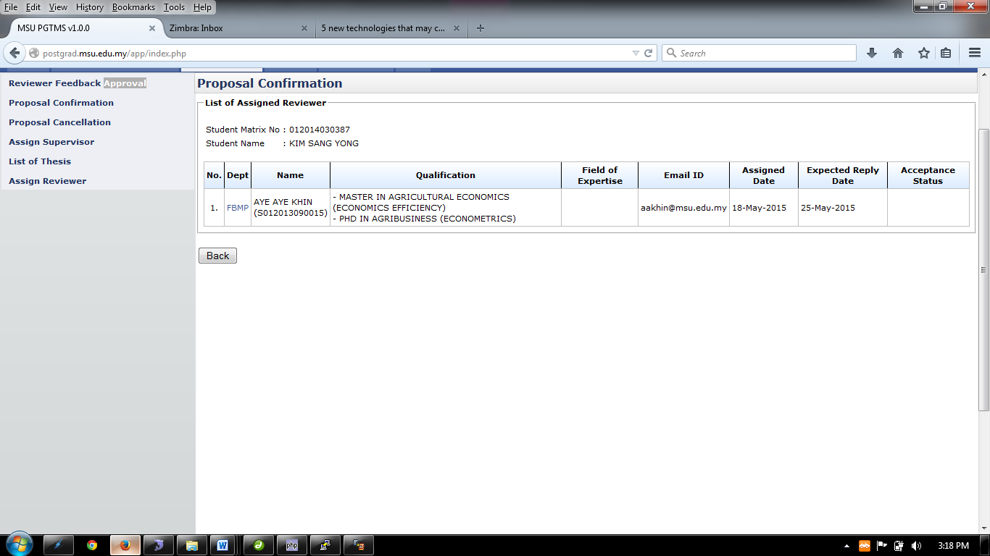

Figure 36: Proposal Confirmation – List of Assigned Reviewer

**Steps:-**

1. This page only displays the assigned reviewer.
2. Then click **Back** button.

#### Change Assign Reviewer

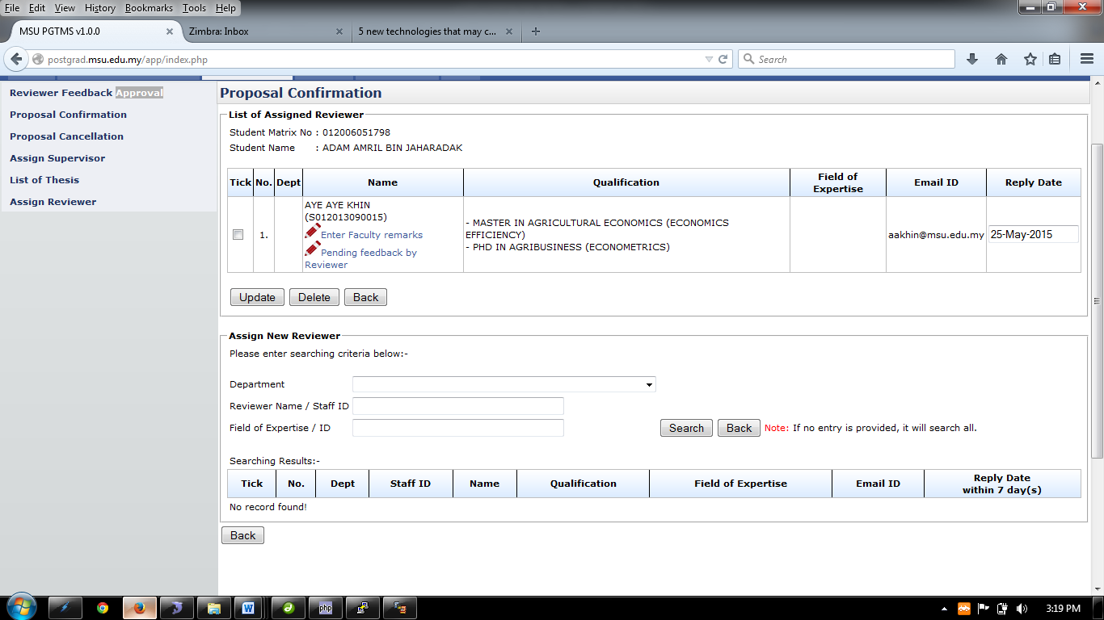

Figure 37: Proposal Confirmation – List of Assigned Reviewer

**Steps:-**

1. To assign new Reviewer. Choose the department of the reviewer on **Department**, enter the **Staff Name/Staff ID** and **Field of Expertise** and then click the **Search** button to search.
2. If there is no entry provided, the search will display all the staff.
3. Next Step is on the next page

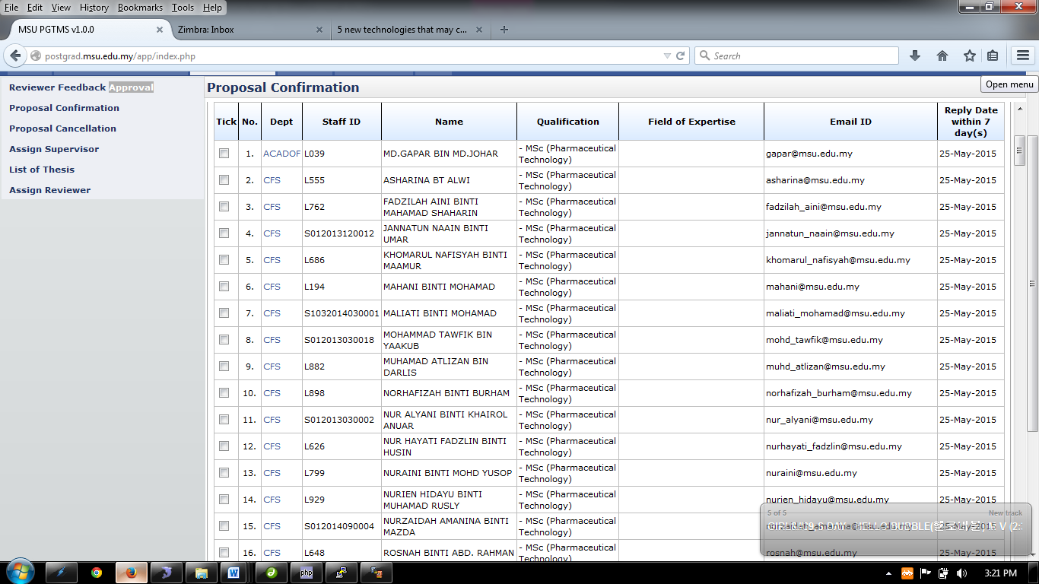

Figure 38: Proposal Confirmation – List All Reviewers (If no search criteria is provided)

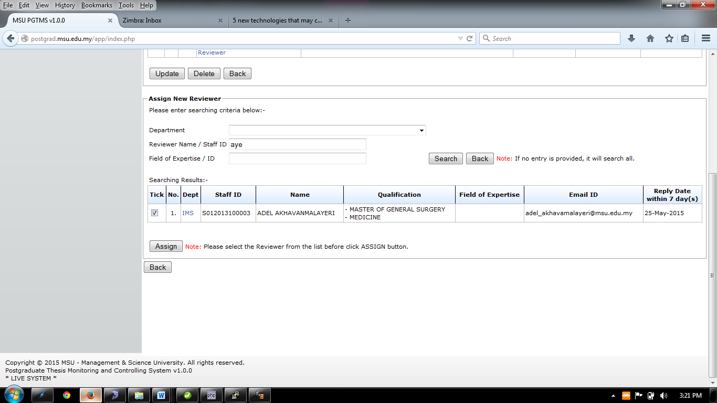

Figure 39: Proposal Confirmation – List of Reviewer (based on provided search criteria)

1. Choose the staff that the user wants to assign by ticking the checkbox.
2. By default, reply date will be set to 7 days starting the day that been assigned.
3. After the entire step done, click **Assign** button.
4. Then click **Back** button.
5. Tick the Staff detail and click **Delete** button to remove the assigned supervisor/co-supervisor
6. To enter remark of the staff click 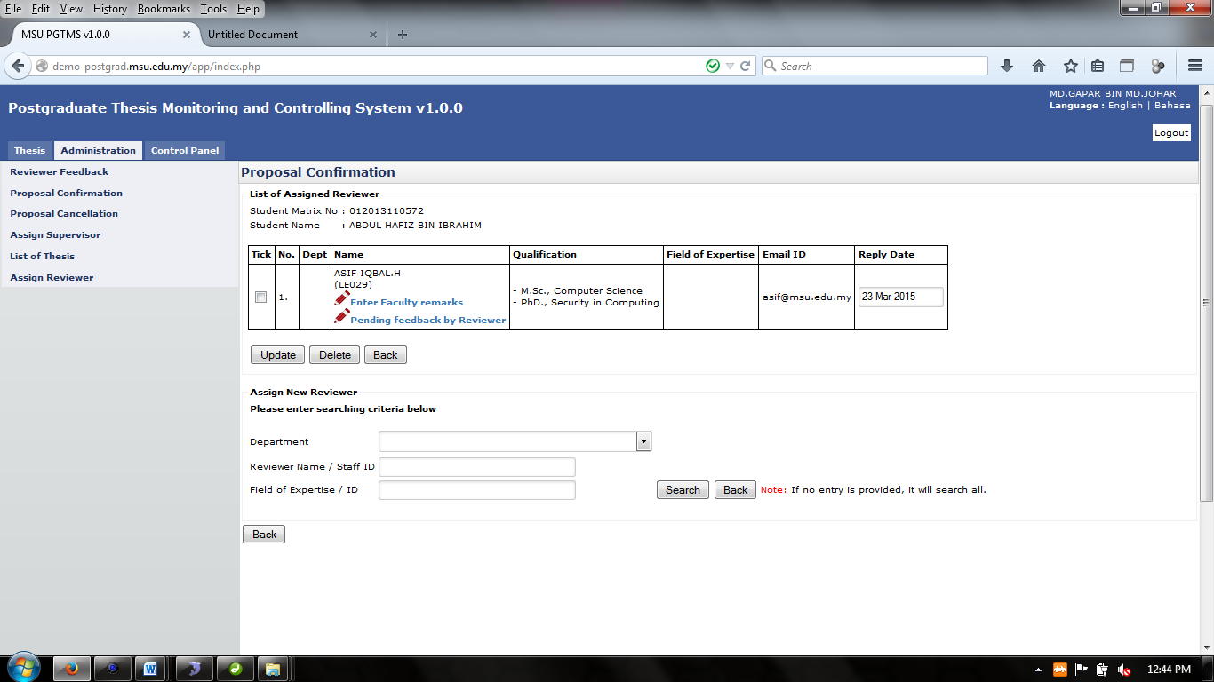.
7. To change the role, choose the **Role** listed.
8. Then click **Update** button.

##### Enter Faculty Remark

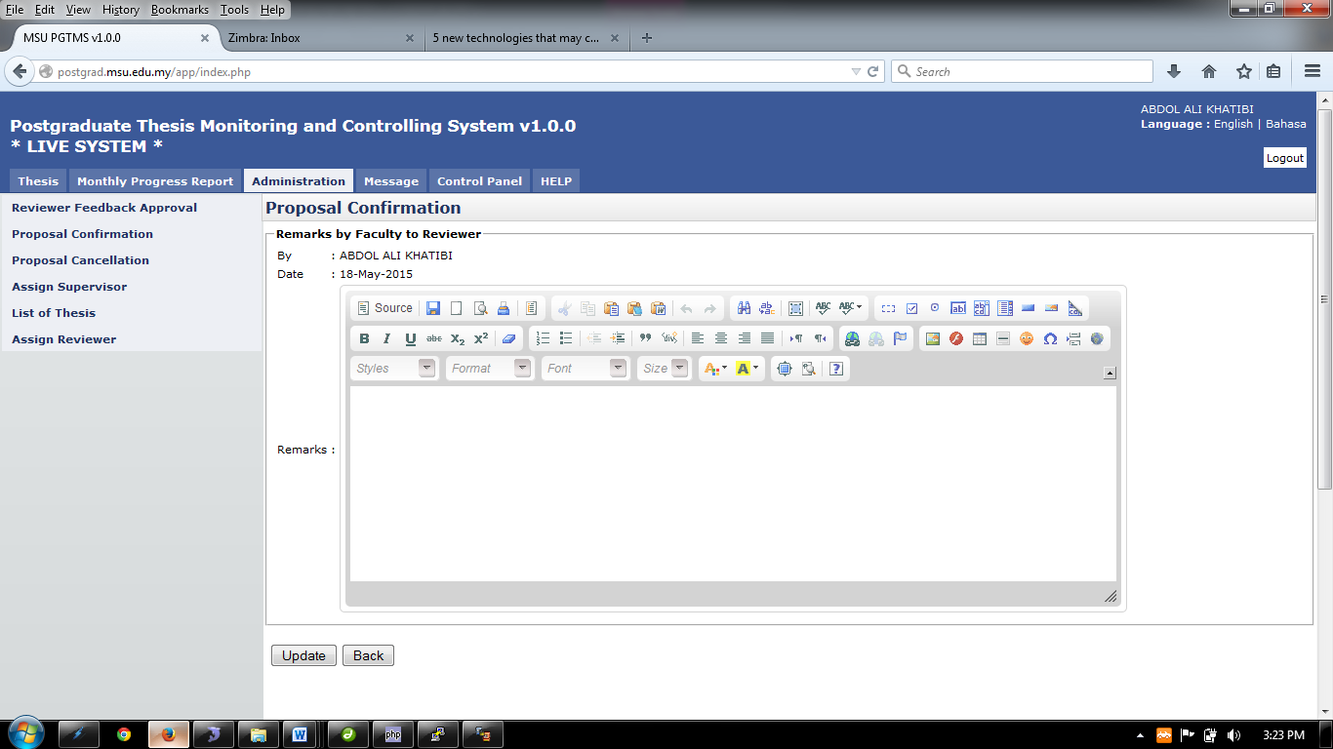

Figure 40: Proposal Confirmation – Remarks by Faculty to Reviewer

**Steps:-**

1. Insert necessary description into the **Remarks** and then click **Update** button
2. Then click **Back** button.

## Proposal Cancellation

Proposal Cancellation is a feature provided to the Faculty to approve the cancellation request to the submitted proposal by the student. This will enable the student to do the required changes before it can be resubmitted again.

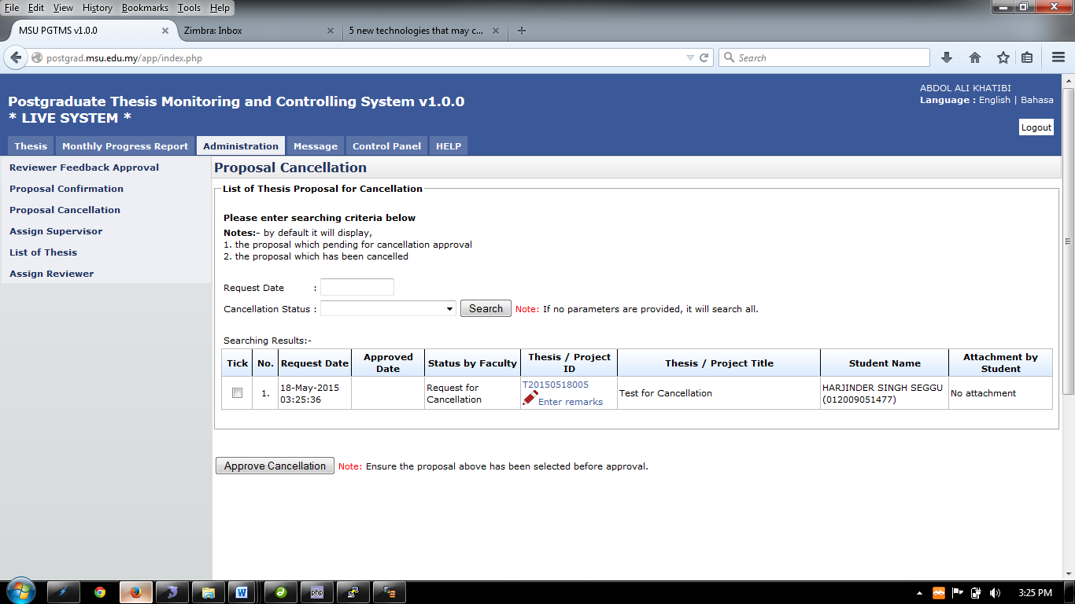

Figure 41: Administration Tab – Proposal Cancellation Page

**Pre-condition**

1. List of student apply for proposal cancellation

**Post-condition**

1. Proceed to proposal confirmation process
2. Assign reviewer

**Steps:-**

1. Click on the **Administration** tab on the system **Top** panel section.
2. The **Administration** menu will be displayed on the system **Left** panel and click on it.
3. Click the **Proposal Cancelation** and the searching page will be displayed which the user can search for a particular proposal which is request for cancellation and proposal that has been cancelled.
4. The result can be search by choose the date of cancelation which is **Request Date** and **Cancellation Status** and click on **Search** button.
5. The record will be displayed under the search result.
6. If neither one of the fill is not chosen, the result will display all list of cancellation data.
7. To give remarks, click on the link 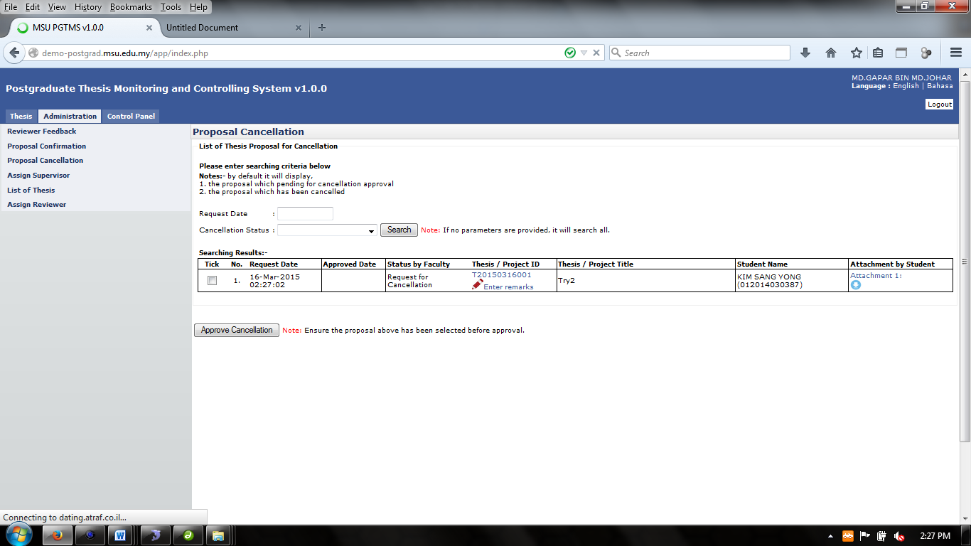for proceed. (Look at **6.3.1: Enter Remarks Cancellation**)
8. To read or download attachment/file, click.
9. To approve the cancellation, tick the checkbox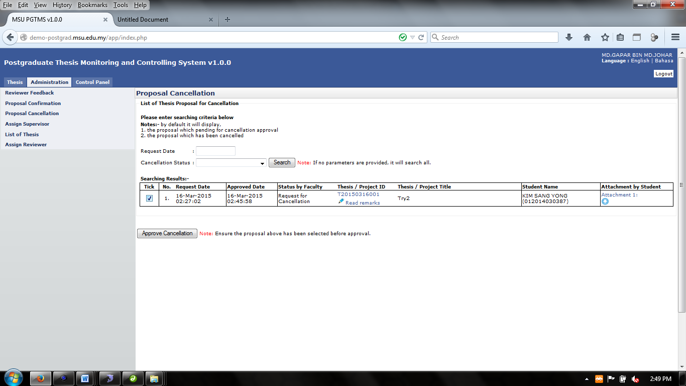.
10. Then click **Approve Cancellation** button to proceed. The status now will be updated from *Request for Cancellation* to *Cancellation Approved*.

### Enter Remark Cancellation

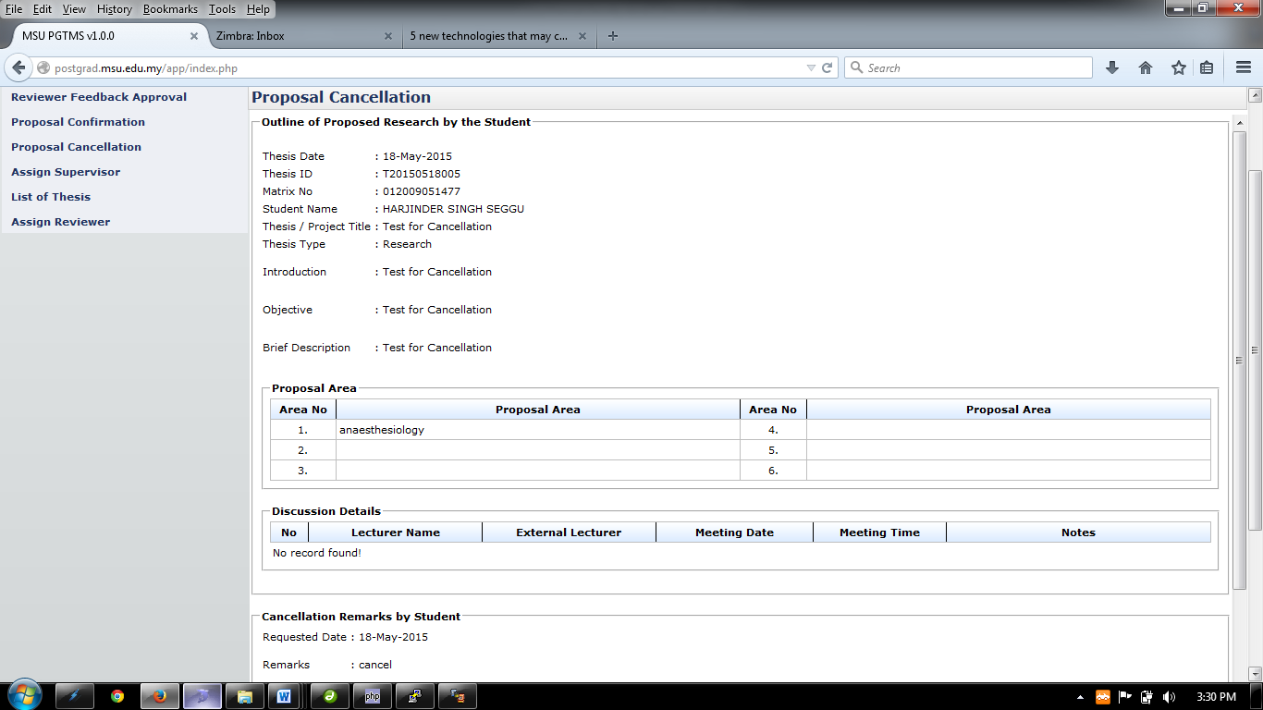

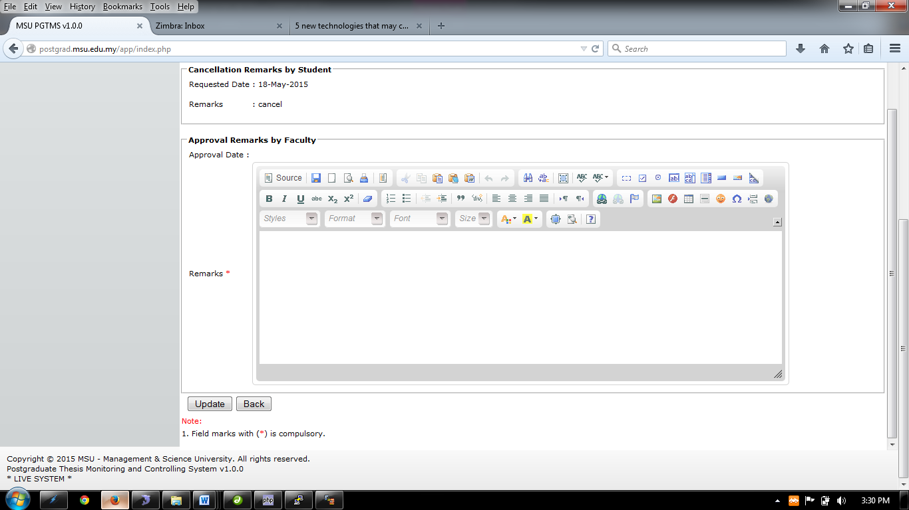

Figure 42: Administration Tab – Remark Cancellation Page

**Steps:-**

1. Insert necessary into **Remarks** field.
2. Click **Update** button and click **Back** to return previous page.

## Assign Supervisor

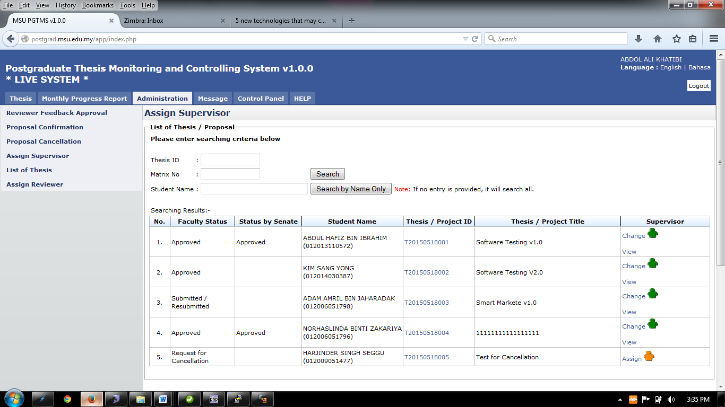

Figure 43: Administration Tab – List of Student under the Assign Supervisor Page

**Pre-condition**

1. Student submit new thesis proposal

**Post-condition**

1. Proceed to proposal confirmation
2. Assign reviewer

**Steps:-**

1. Click on the **Administration** tab on the system **Top** panel section.
2. The **Administration** menu will be displayed on the system **Left** panel and click on it.
3. Click the **Assign Supervisor** and the searching page will be displayed which the user can search for a particular thesis to assign it supervisor/co-supervisor. Otherwise, the result will show the entire listed thesis.
4. Enter the **Thesis’s ID** or **Matrix No** into the field and click on **Search** button.
5. The record will be displayed under the search result.
6. **Or** it can be search via **Student Name** by enter the student name and click **Search by Student Name Only.**
7. The record will be displayed under the search result
8. Otherwise the result will display all listed result.
9. To assign Supervisor/Co-Supervisor Click  at **Supervisor/Co-Supervisor** column.
10. To view the assigned staff, click .
11. To change the assigned staff, click .

#### Assign Supervisor/Co-Supervisor

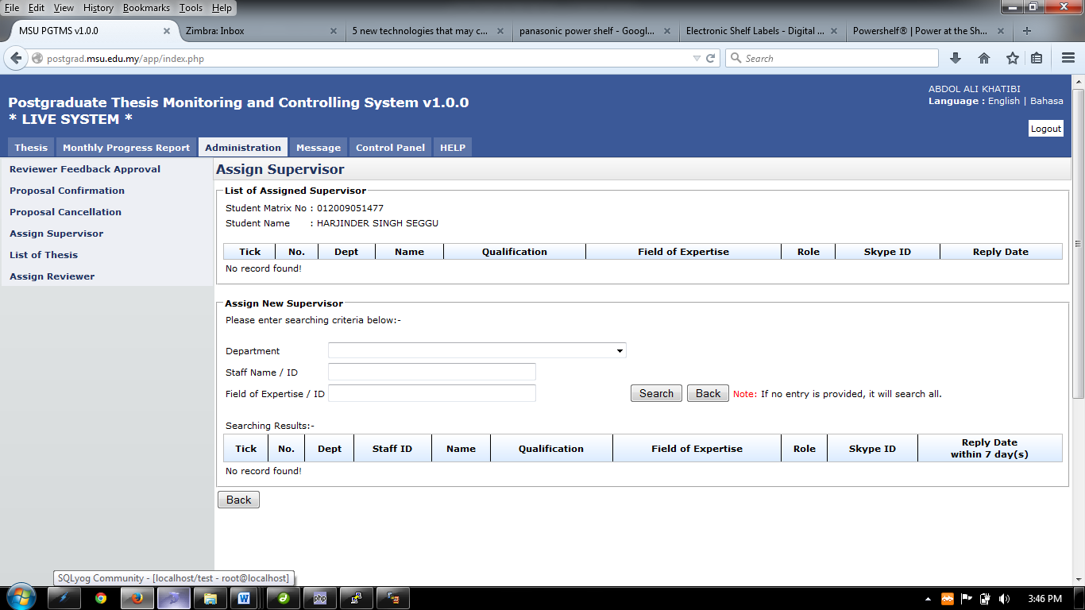

Figure 44: Administration Tab – Assign Supervisor/Co-Supervisor Page

**Steps:-**

1. Choose the department of the supervisor on **Department**, enter the **Staff Name/Staff ID** and **Field of Expertise** and then click the **Search** button to search.
2. If there is no entry provided, the search will display all the staff.
3. Next Step is on the next page

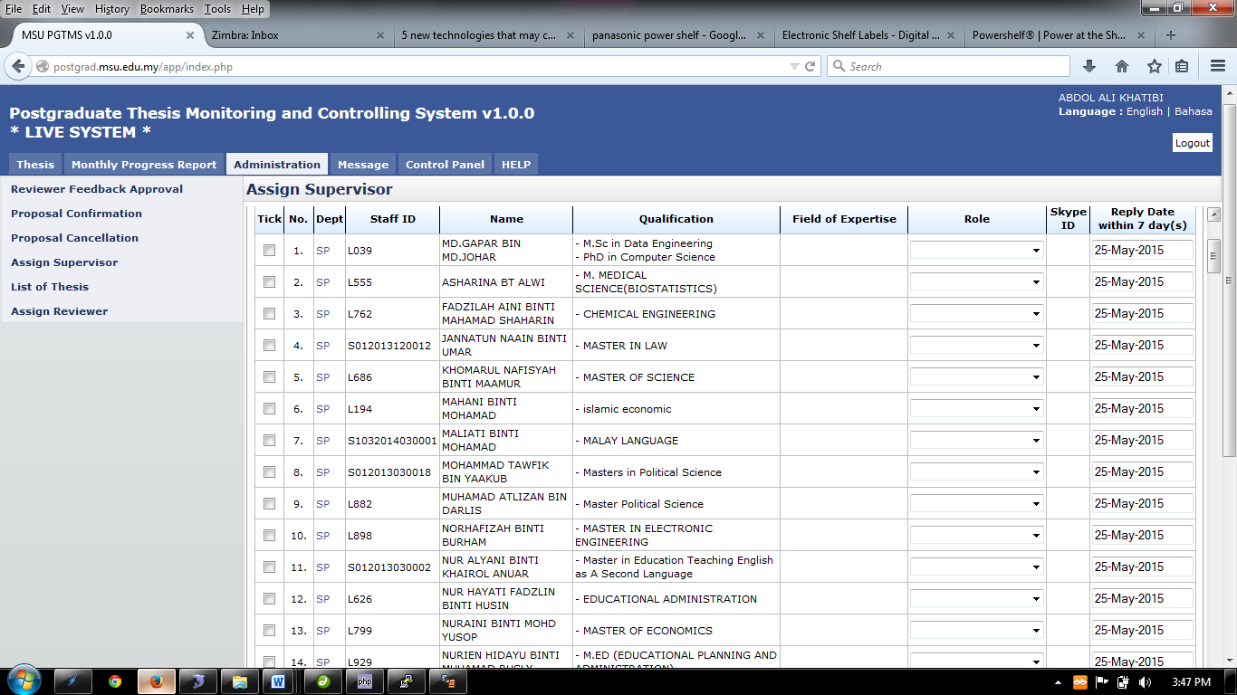

Figure 45: Administration Tab – List of Staff for Supervisor / Co-Supervisor Selection

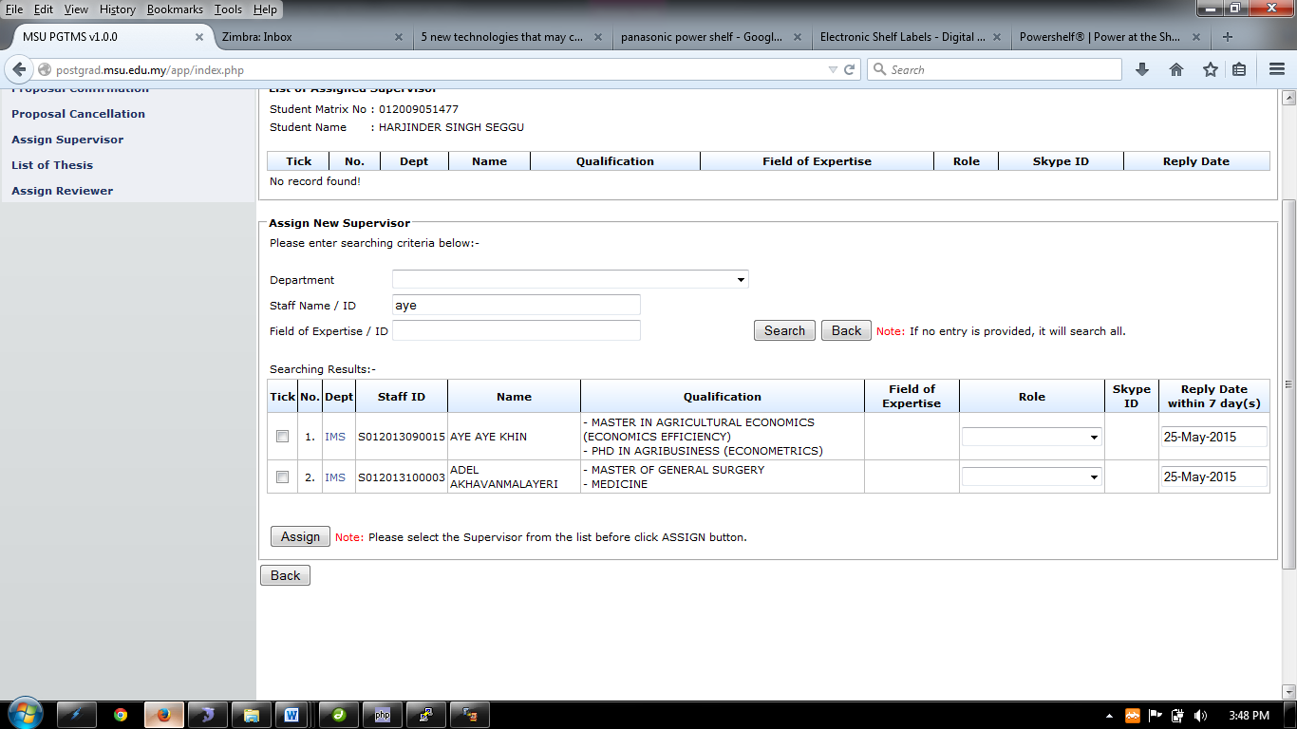

Figure 46: Administration Tab – Supervisor/Co-Supervisor Search Result

1. Choose the staff that the user wants to assign by ticking the checkbox.
2. Then choose the role of the assigned staff whether to be Supervisor & Co-Supervisor
3. Then choose the **Reply Date**
4. After the entire step done, click **Assign** button.
5. Then click **Back** button.

#### View Assigned Supervisor/Co-Supervisor

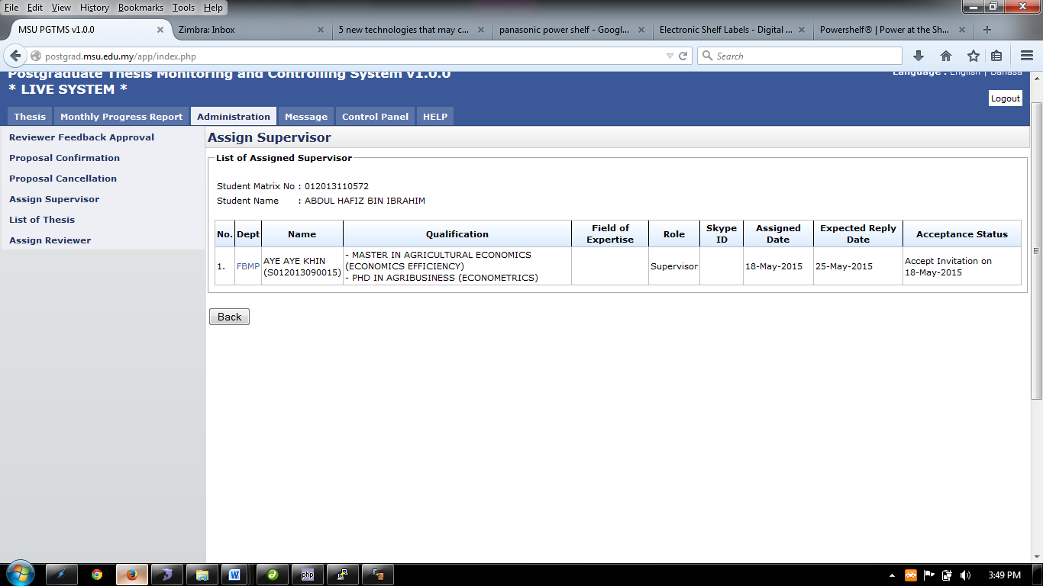

Figure 47: Administration Tab – List of Assigned Supervisor/Co-Supervisor

**Steps:-**

1. This page only displays the assigned supervisor/co-supervisor.
2. Then click **Back** button.

#### Change Assign Supervisor/Co-Supervisor

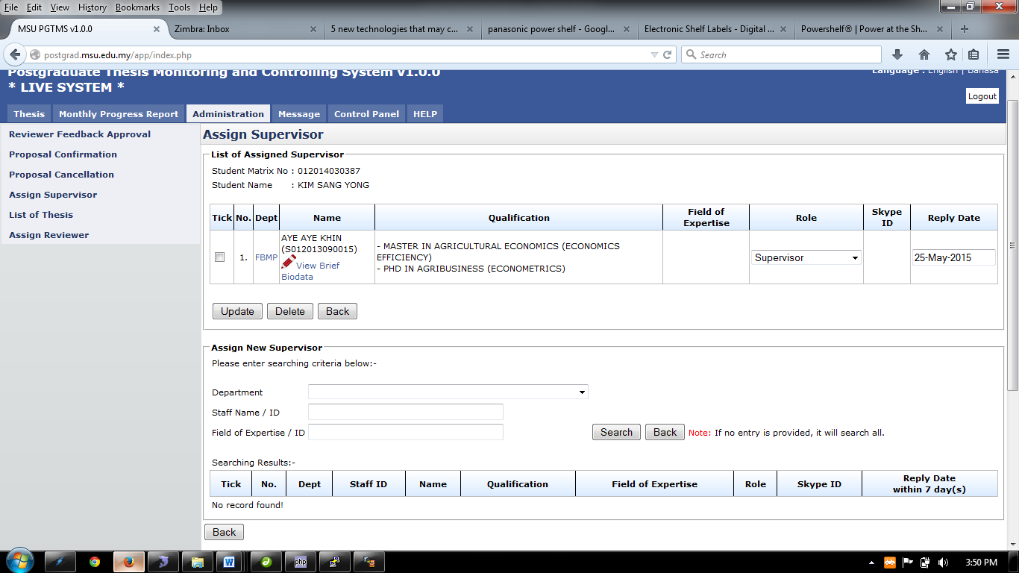

Figure 48: Administration Tab – List of Supervisor/Co-Supervisor for Update

**Steps:-**

1. To assign new Supervisor/Co-supervisor. Choose the department of the supervisor on **Department**, enter the **Staff Name/Staff ID** and then click the **Search** button to search.
2. If there is no entry provided, the search will display all the staff. (Look at Figure 9.0)
3. Next Step is on the next page



Figure 49: Assign Supervisor – List of Staff (If no search criteria are provided)

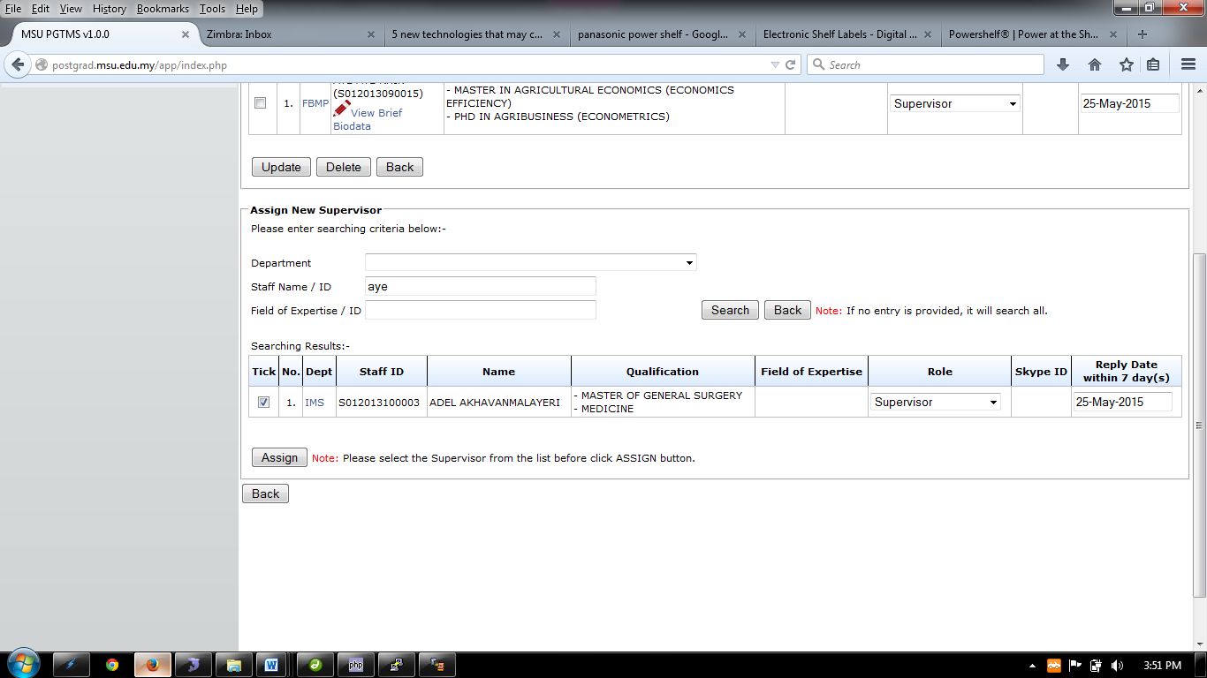

Figure 50: Assign Supervisor – List of Staff (based on provided search criteria)

1. Choose the staff that the user wants to assign by ticking the checkbox.
2. Then choose the role of the assigned staff whether to be Supervisor or Co-Supervisor.
3. Then choose the **Reply Date**
4. After the entire step done, click **Assign** button.
5. Then click **Back** button.
6. Tick the Staff detail and click **Delete** button to remove the assigned supervisor/co-supervisor
7. To add/view brief biodata of the staff click .
8. To change the role, choose the **Role** listed.
9. Then click **Update** button.

##### View Brief Biodata

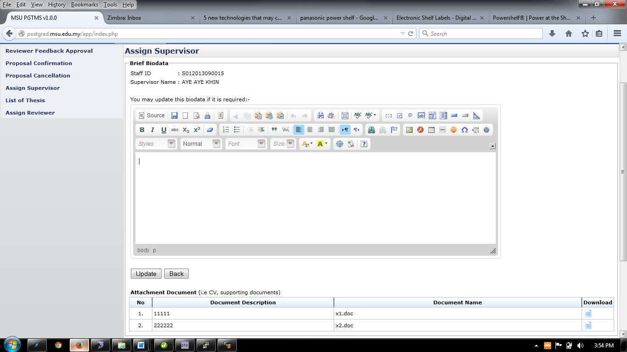

Figure 51: Assign Supervisor – Supervisor / Co-Supervisor Biodata Page for Update

**Steps:-**

1. Insert necessary description into the **Biodata** and then click **Update** button
2. To download necessary document such as supporting document, click  to download.
3. Then click **Back** button.

## Assign Reviewer

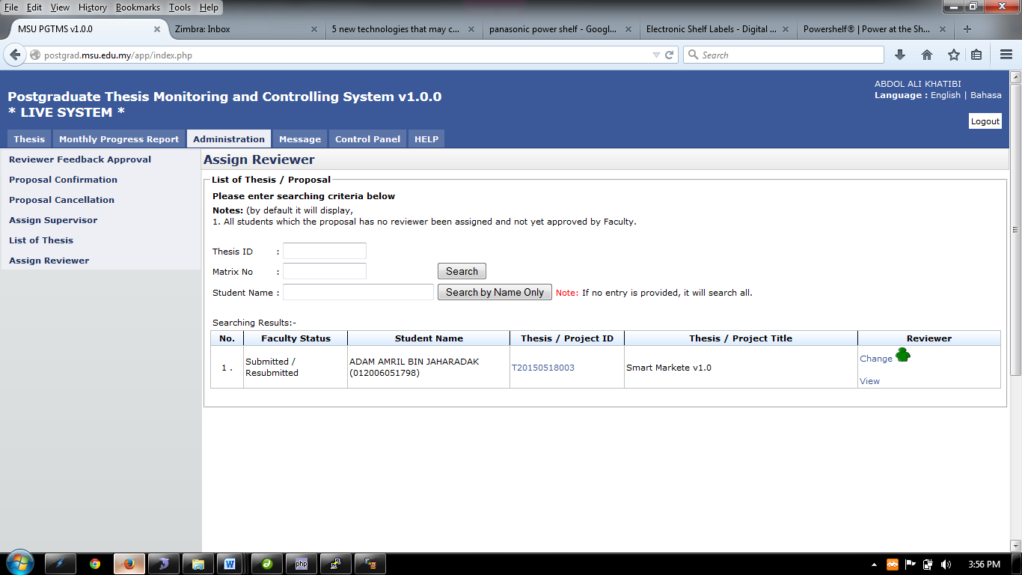

Figure 52: Assign Reviewer – List of Student

**Pre-condition**

1. List of new thesis proposal by student

**Post-condition**

1. Wait for reviewer to review the thesis
2. Proceed to proposal confirmation

**Steps:-**

1. Click on the **Administration** tab on the system **Top** panel section.
2. The **Administration** menu will be displayed on the system **Left** panel and click on it.
3. Click the **Assign Reviewer** and the searching page will be displayed which the user can search for a particular thesis to assign it reviewer. Otherwise, the result will show the entire listed thesis.
4. Enter the **Thesis’s ID** or **Matrix No** into the field and click on **Search** button.
5. The record will be displayed under the search result.
6. **Or** it can be search via **Student Name** by enter the student name and click **Search by Student Name Only.**
7. The record will be displayed under the search result
8. Otherwise the result will display all listed result.
9. To assign Reviewer Click  at **Reviewer** column.
10. To view the assigned reviewer, click.
11. To change the assigned Reviewer, click.

#### Assign Reviewer

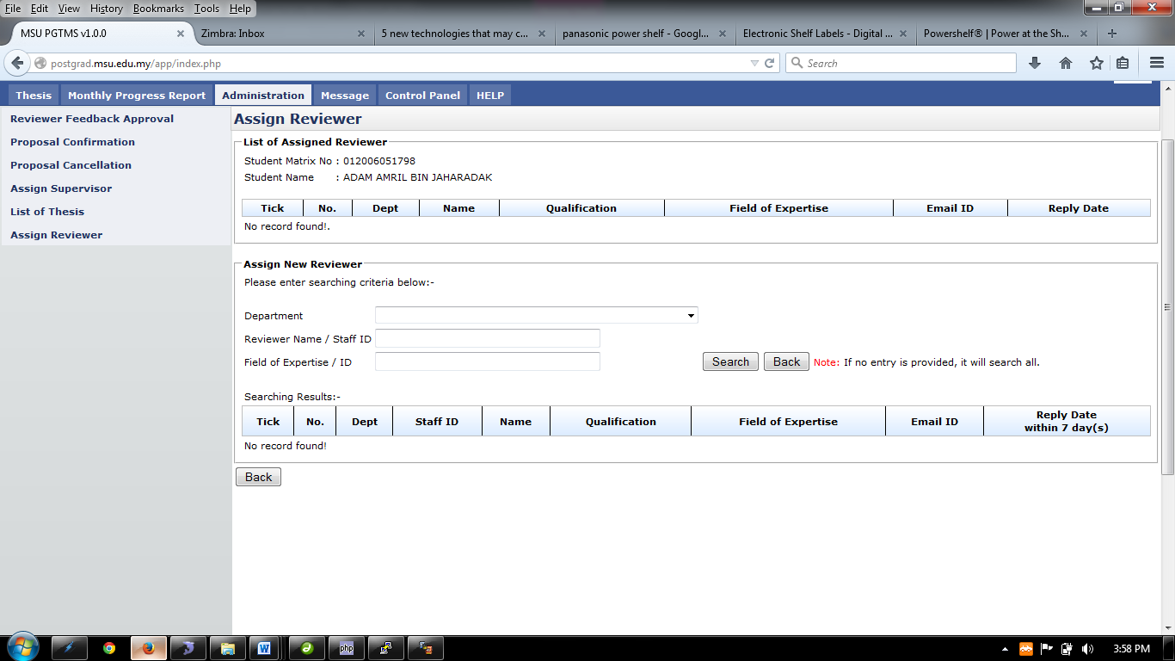

Figure 53: Assign Reviewer Page

**Steps:-**

1. Choose the department of the reviewer on **Department**, enter the **Reviewer Name/Staff ID** and **Field of Expertise** and then click the **Search** button to search.
2. If there is no entry provided, the search will display all the staff. (Look at Figure 9.5)
3. Next Step is on the next page

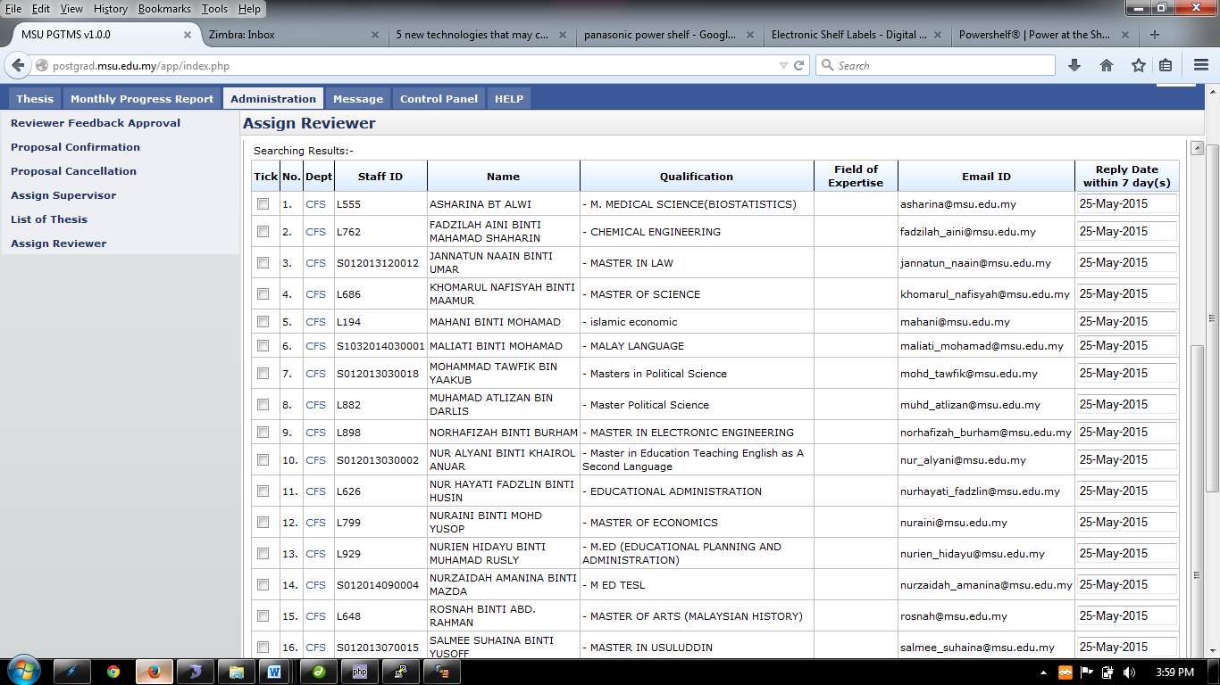

Figure 54: Assign Reviewer Search Result (If no search criteria is provided)

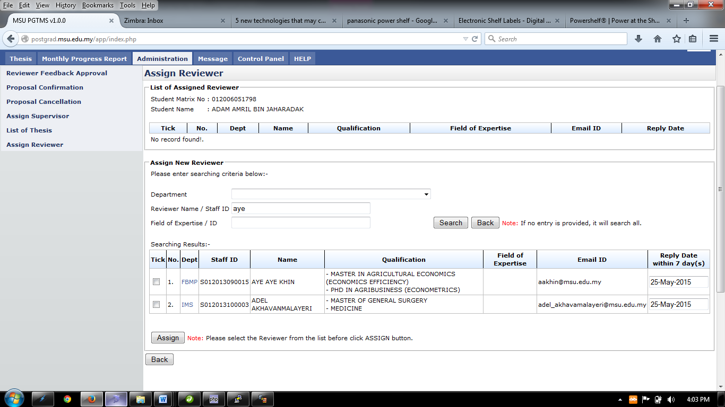

Figure 55: Assign Reviewer Search Result (Based on provided search criteria)

1. Choose the staff that the user wants to assign by ticking the checkbox.
2. Then choose the **Reply Date**
3. After the entire step done, click **Assign** button.
4. Then click **Back** button.

#### View Assigned Reviewer

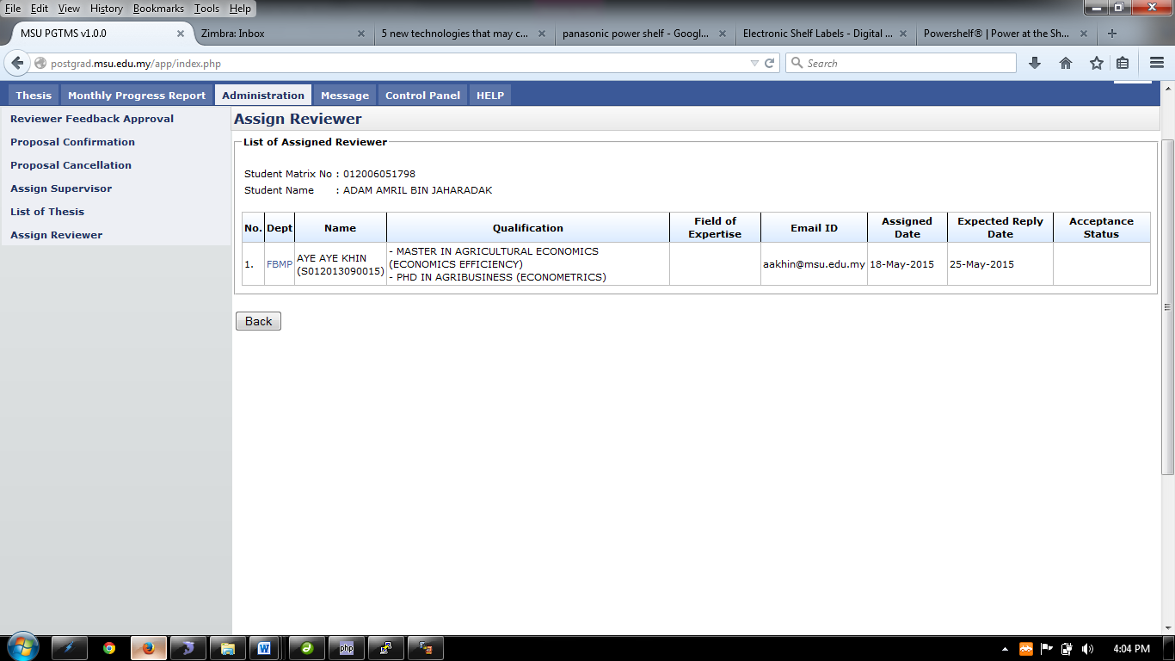

Figure 56: List of Assigned Reviewer Page

**Steps:-**

1. This page only displays the assigned reviewer.
2. Then click **Back** button.

#### Change Assign Reviewer

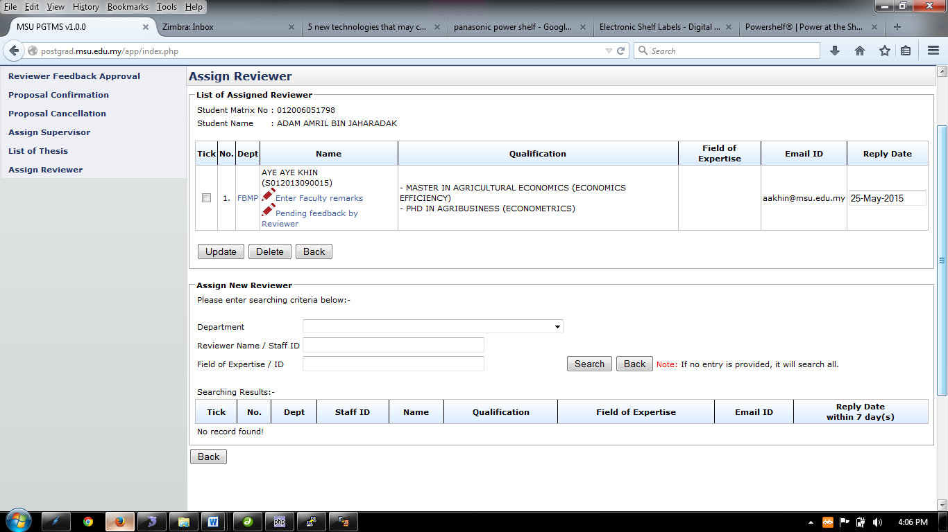

Figure 57: List of Assigned Reviewer for Update

**Steps:-**

1. To assign new Reviewer. Choose the department of the reviewer on **Department,** enter the **Staff Name/Staff ID** and **Field of Expertise** and then click the **Search** button to search.
2. If there is no entry provided, the search will display all the staff. (Look at Figure 9.9)
3. Next Step is on the next page



Figure 58: Assign Reviewer Search Result (If no search criteria are provided)



Figure 59: Assign Reviewer Search Result (Based on provided search criteria)

1. Choose the staff that the user wants to assign by ticking the checkbox.
2. Then choose the **Reply Date**
3. After the entire step done, click **Assign** button.
4. Then click **Back** button.
5. Tick the Staff detail and click **Delete** button to remove the assigned supervisor/co-supervisor
6. To enter remark of the staff click .
7. To change the role, choose the **Role** listed.
8. Then click **Update** button.

##### Enter Faculty Remark

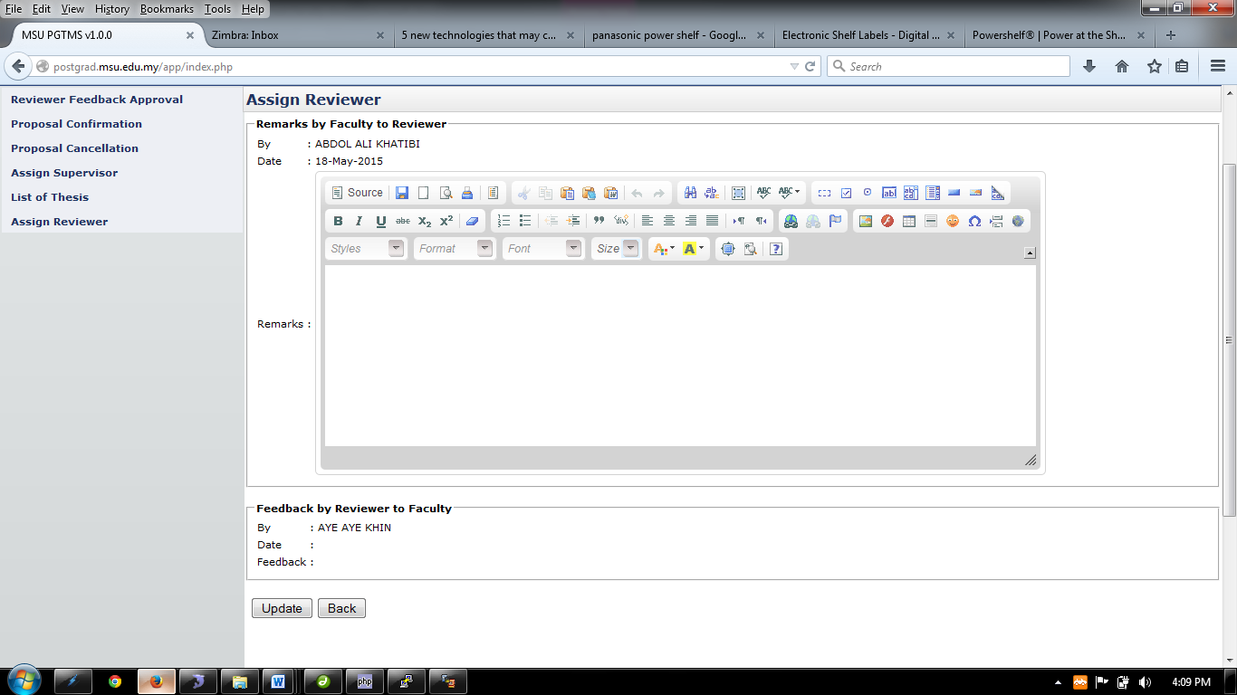

Figure 60: Assign Reviewer – Enter Faculty Remark

**Steps:-**

1. Insert necessary description into the **Remarks** and then click **Update** button
2. Then click **Back** button.

## List of thesis proposal – Disapproved thesis by Senate

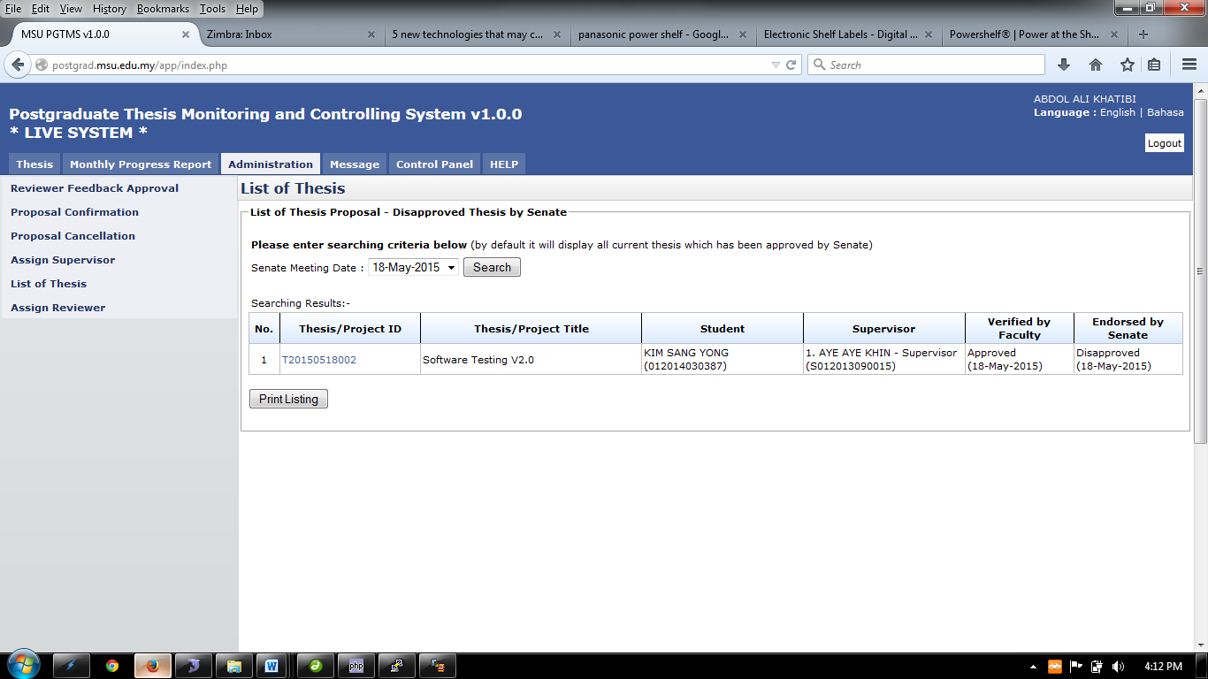

Figure 61: Administration Tab – List of Disapproved Thesis

**Pre-condition**

1. List of disapproved thesis

**Post-condition**

1. Wait for reviewer to review the thesis
2. Proceed to proposal confirmation

**Steps:-**

1. Click on the **Administration** tab on the system **Top** panel section.
2. The **List of Thesis** menu will be displayed on the system **Left** panel and click on it.
3. The searching page will be displayed which the user can search for a particular thesis that have been disapproved by senate in order to view its detail
4. Select the **Senate Meeting Date** at the field and click on **Search** button to search the thesis
5. The record will be displayed under the search result.
6. To print the detail, click **Print Listing** button to proceed.

## Generate File

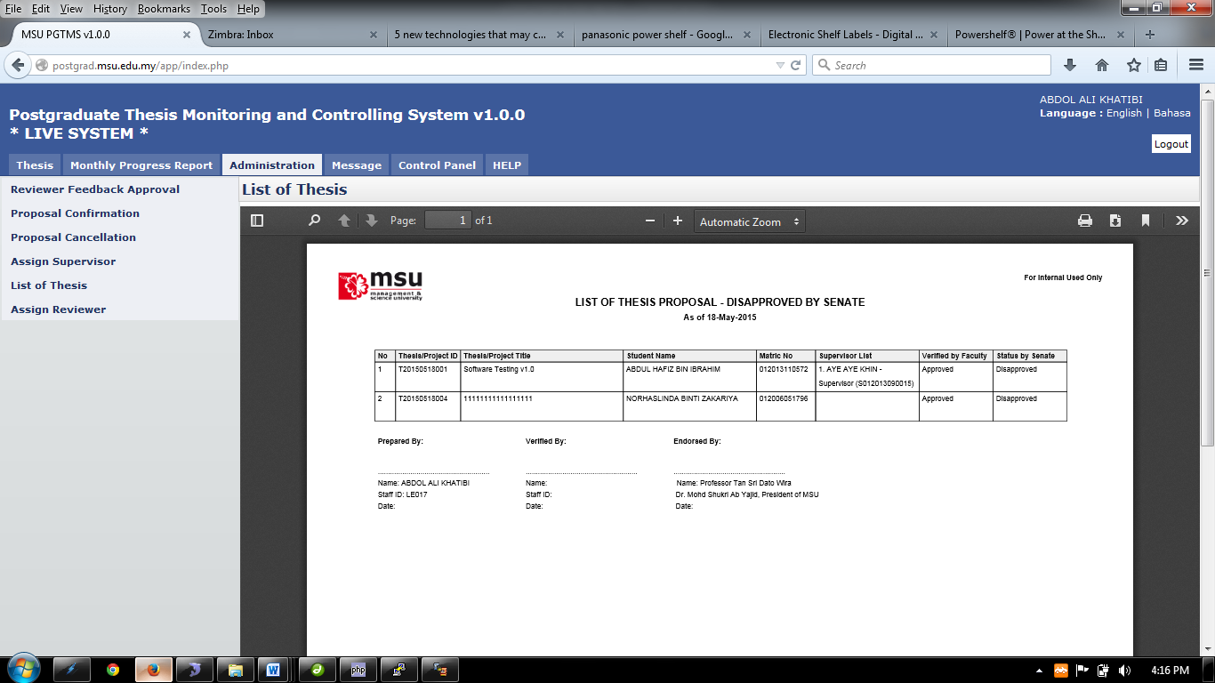

Figure 62: List of Disapproved Thesis PDF

**Steps:-**

1. To print, click the print logo button  to print.
2. To save file (PDF) click the download logo button 

APPENDIX

# Email Template - Faculty to Student

## Thesis Proposal - Request Change

To: [mdgapar@msu.edu.my](mailto:mdgapar@msu.edu.my) <[mdgapar@msu.edu.my](mailto:mdgapar@msu.edu.my)>

From: [kimsangyong@msu.edu.my](mailto:kimsangyong@msu.edu.my) <[kimsangyong@msu.edu.my](mailto:kimsangyong@msu.edu.my)>

Cc: [kimsangyong@msu.edu.my](mailto:kimsangyong@msu.edu.my) <[kimsangyong@msu.edu.my](mailto:kimsangyong@msu.edu.my)>

Subject: Thesis Proposal by KIM SANG YONG – Submitted



|  |  |
| --- | --- |
| Dear NURUL AIN BINTI MOHD SAID, |  |
| Please be informed, your thesis proposal status has been responded by the Faculty with the following status. |  |
|  |  |

|  |  |
| --- | --- |
| **Student Name** | NURUL AIN BINTI MOHD SAID |
| **Matric No** | 012012051680 |
| **Thesis ID** | T20150513003 |
| **Submit Date** | 13-May-2015 |
| **Thesis/Project Title** | 33333333- edit_proposal.php |
| **Proposal Type** | Research |
| **Faculty Proposal Status** | Request Changes |

Thank you,

Best Regards,

Management & Science University

Please do not reply directly to this email. © MSU 2015All rights reserved.  
  
Management & Science University.  
University Drive, Off Persiaran Olahraga,  
Section 14, 40100 Shah Alam,  
Selangor Darul Ehsan.

## Thesis Proposal - Disapproved

To: [mdgapar@msu.edu.my](mailto:mdgapar@msu.edu.my) <[mdgapar@msu.edu.my](mailto:mdgapar@msu.edu.my)>

From: [kimsangyong@msu.edu.my](mailto:kimsangyong@msu.edu.my) <[kimsangyong@msu.edu.my](mailto:kimsangyong@msu.edu.my)>

Cc: [kimsangyong@msu.edu.my](mailto:kimsangyong@msu.edu.my) <[kimsangyong@msu.edu.my](mailto:kimsangyong@msu.edu.my)>

Subject: Thesis Proposal by KIM SANG YONG – Submitted



|  |  |
| --- | --- |
| Dear NURUL AIN BINTI MOHD SAID, |  |
| Please be informed, your thesis proposal status has been responded by the Faculty with the following status. |  |
|  |  |

|  |  |
| --- | --- |
| **Student Name** | NURUL AIN BINTI MOHD SAID |
| **Matric No** | 012012051680 |
| **Thesis ID** | T20150513003 |
| **Submit Date** | 13-May-2015 |
| **Thesis/Project Title** | 33333333- edit_proposal.php |
| **Proposal Type** | Research |
| **Faculty Proposal Status** | Disapproved |

Thank you,

Best Regards,

Management & Science University

Please do not reply directly to this email. © MSU 2015All rights reserved.  
  
Management & Science University.  
University Drive, Off Persiaran Olahraga,  
Section 14, 40100 Shah Alam,  
Selangor Darul Ehsan.

This page is intentionally left blank.